To find the equation of a circle, I used my knowledge of vectors. The vector equation of a circle defines a mid point, a point on the circle and the distance between them. To convert the given points into the vector equation, I simply substituted the points given as position vectors. The three equations I got for the first example are:
$$\left|\begin{matrix}3 \\ 2\end{matrix}+\begin{matrix}-x \\ -y\end{matrix}\right|=r$$
$$\left|\begin{matrix}3 \\ 6\end{matrix}+\begin{matrix}-x \\ -y\end{matrix}\right|=r$$
$$\left|\begin{matrix}5 \\ 8\end{matrix}+\begin{matrix}-x \\ -y\end{matrix}\right|=r$$
Where r is the radius, and $x$ and $y$ are the mid point coordinates. From this, we can convert it into three equations to solve simultaneously:
$${(3-x)}^{2}+{(2-y)}^{2}=r^{2}$$
$${(3-x)}^{2}+{(6-y)}^{2}=r^{2}$$
$${(5-x)}^{2}+{(8-y)}^{2}=r^{2}$$
As a result, I got $r=2\sqrt{5}$, $x=7$ and $y=4$. Then from this I wrote the circle equation as ${(x-7)}^{2}+{(y-4)}^{2}=20$.

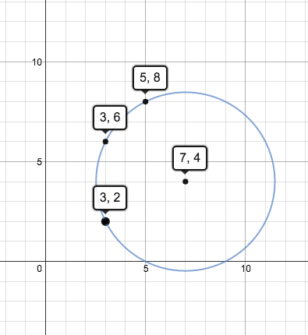

I checked this on a graphing program and it satisfies the parameters specified.

