Finding Circles
Stephen T
To find a unique circle we need 3 (distinct) points and their coordinates. 2 points is not enough information and 4 points won’t always have all points lie on a circle. The rare occasion that is does is called a cyclic quadrilateral. A Cyclic quadrilateral is defined when opposite angles of a quadrilateral sum to equal 180º. The equation of a circle requires the coordinates of the mid point for the standard form shown.
$$r^{2}={\left(X-a\right)}^{2}+{\left(Y-b\right)}^{2}$$
The general form for a circle is
$$x^{2}+y^{2}+Cx+Dy+E=0$$
Where (a,b) is the x and y coordinates of the midpoint of the circle
Therefore, all that needs to be determined are methods of determining the midpoint of the circle from 3 points.

Method 1: Using Bisectors of 2 chords
Points: A(0,4) B(4,0) C(-6,0)
From 3 points construct 2 chords, AB and BC

Firstly find the midpoints of both chords.
$$Mid point=\left(\frac{x_{1}+x_{2}}{2},\frac{y_{1}+y_{2}}{2}\right)$$
$$Mid point of AB=\left(\frac{0+4}{2},\frac{4+0}{2}\right)=\left(2,2\right)$$
$$Mid point of AC=\left(\frac{0+-6}{2},\frac{4+0}{2}\right)=\left(-3,2\right)$$
Find the gradient of the Chords
$$Gradient=\left(\frac{y_{2}-y_{1}}{x_{2}-x_{1}}\right)$$
$$Gradient of AB=\left(\frac{0-4}{4-0}\right)=-1$$
$$Gradient of AC=\left(\frac{0-4}{-6-0}\right)=\frac{2}{3}$$
Let L1 be perpendicular to AB
Let L2 be perpendicular of AC
$$⊥gradient=\frac{-1}{Gradient}$$
$$gradient of L1=\frac{-1}{-1}=1$$
$$gradient of L2=\frac{-1}{2/3}=\frac{-3}{2}$$

Input the midpoints of the lines to determine L1 and L2 in slope-intercept form
$$y=mx+c$$
$$L1:2=1×2+c$$
$$L1:c=0$$
$$L1:y=x$$

$$L2:2=\frac{-3}{2}×-3+c$$
$$L2:c=-2.5$$
$$L2:y=\frac{-3}{2}x-2.5$$

The mid-point of the circle is where the perpendicular lines from the mid-points of 2 chords meet. So when L1 = L2
$$midpoint:L1=L2$$
$$x=\frac{-3}{2}x-2.5$$
$$x=-1$$
Substitute the x value into either L1 or L2 to give a y value for the mid-point of the circle
$$L1:y=x$$
$$L1:-1=-1$$
$$(-1,-1)$$
Solve for radius using and of the original points and the centre in the standard form of a circle. Here Lets use A

$$r=\sqrt{{\left(x-a\right)}^{2}+{\left(Y-b\right)}^{2}}$$
$$r=\sqrt{{\left(0--1\right)}^{2}+{\left(4--1\right)}^{2}}$$
$$r=\sqrt{1+25}$$
$$r=\sqrt{26}$$
Simplifying to a surd allows easier use of the equation
The equation of the circle is now
$$r^{2}={\left(X-a\right)}^{2}+{\left(Y-b\right)}^{2}$$
$${\sqrt{26}}^{2}={\left(X+1\right)}^{2}+{\left(Y+1\right)}^{2}$$
$$26={\left(X+1\right)}^{2}+{\left(Y+1\right)}^{2}$$
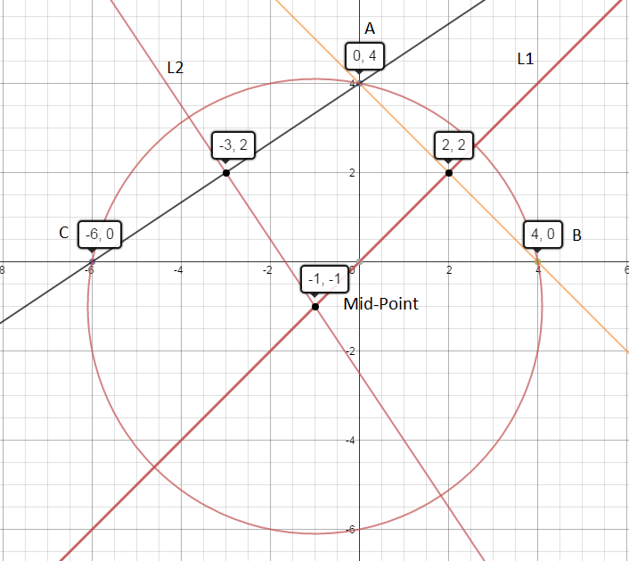

Method 2: Centre and Radius form
The three points given are all the same distance from the Centre, i.e the radius
Let the centre of the circle be O and the mid-point of the circle (a,b)
A (-1,-5) B(4,0) C(-6,0)
$$\left|AO\right|=\left|BO\right|=\left|CO\right|$$
Since all of these lines are equal to the radius we can substitute in the standard form of a circle
$$r^{2}={\left(X-a\right)}^{2}+{\left(Y-b\right)}^{2}$$

$${\left|AO\right|}^{2}={\left|BO\right|}^{2}={\left|CO\right|}^{2}$$
$${\left(X-a\right)}^{2}+{\left(Y-b\right)}^{2}={\left(X-a\right)}^{2}+{\left(Y-b\right)}^{2}={\left(X-a\right)}^{2}+{\left(Y-b\right)}^{2}$$

Input the applicable x and y values for each of the points A, B and C
$${\left(-1-a\right)}^{2}+{\left(-5-b\right)}^{2}={\left(4-a\right)}^{2}+{\left(0-b\right)}^{2}={\left(-6-a\right)}^{2}+{\left(0-b\right)}^{2}$$
Expand
$$a^{2}+b^{2}+2a+10b+26=a^{2}+b^{2}-8a+16=a^{2}+b^{2}+12a+36$$
Now all of the square terms can be remove from the equation as there are in every expression.
$$2a+10b+26=16-8a=12a+36$$
Now we can use simultaneous to solve for a and b
$$\left\{\begin{aligned}2a+10b+26=16-8a \\ 16-8a=12a+36\end{aligned}\right.$$
Find common factors
$$\left\{\begin{aligned}a+5b+13=8-4a \\ 4-2a=3a+9\end{aligned}\right.$$

Here for other equations you can either use substitution of elimination however here in the second equation there is on 1 variable. Hence we can solve normally
$$4-2a=3a+9$$
$$4=5a+9$$
$$-5=5a$$
$$a=-1$$
Here we solve for b using a in the first simultaneous equation
$$a+5b+13=8-4a$$
$$-1+5b+13=8+4$$
$$5b+13=13$$
$$5b=0$$
$$b=0$$
(a,b) = (-1,0)
To find the radius we use the mid-point in the standard form
Let’s use B(4,0)
$$r=\sqrt{{\left(X-a\right)}^{2}+{\left(Y-b\right)}^{2}}$$
$$r=\sqrt{{\left(4--1\right)}^{2}+{\left(0-0\right)}^{2}}$$
$$r=\sqrt{{\left(5\right)}^{2}}$$
$$r=5$$
And so the equation is
$$5^{2}={\left(X+1\right)}^{2}+{\left(Y\right)}^{2}$$
We can then create the graph to have a visual conformation that the method worked.
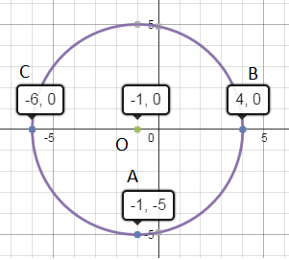
Method 3: Substituting into general form
By using the general form we can substitute in the points to create 3 equations. These 3 equations then can undergo elimination or substitute using simultaneous equations or matrices to solve for the coefficients.
$$x^{2}+y^{2}+Cx+Dy+E=0$$
A(-1,-5) B(-2,2) C(2,-1)
Using the 3 points we substitute them into the general form labelling the equations
$$A: {-1}^{2}+{-5}^{2}+-1C+-5D+E=0$$
$$A: 1+25+-1C+-5D+E=0$$
$$(1 )A: 26=1C+5D-E$$

$$B:{-2}^{2}+2^{2}+-2C+2D+E=0$$
$$B:4+4+-2C+2D+E=0$$
$$\left(2\right)B:8=2C-2D-E$$

$$C: 2^{2}+{-1}^{2}+2C+-1D+E=0$$
$$C: 4+1+2C+-1D+E=0$$
$$\left(3\right)C: 5=-2C+1D-E$$
The 3 equations are as shown
$$(1 )A: 26=1C+5D-E$$
$$\left(2\right)B:8=2C-2D-E$$
$$\left(3\right)C: 5=-2C+1D-E$$
Here we now proceed with preferred methods of simultaneous equations but here is one method:
Firstly -2(1)+(2)
$$\left(4\right)-44=-12D+E$$
Next 2(1)+(3)
$$\left(5\right) 57=11D-3E$$
Lastly 3(4)+(5)
$$\left(6\right)-75=25D$$
$$D=3$$
Substitute D into (4)
$$-44=-12(3)+E$$
$$E=-8$$
Substitute D and E into (1)
$$26=1C+5(3)-(-8)$$
$$C=3$$

Now we have all the coefficients for the general form of a circle
$$x^{2}+y^{2}+3x+3y+8-12=0$$
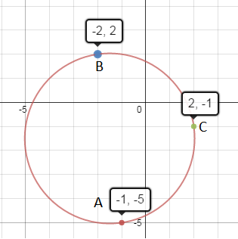

Method 1 is long and is not simplified enough however it is very good starting point as you can understand easily what is happening in each step and how it forms an answer. Methods 2 and 3 are far easier to use in test situations due to the far improvement on the time factor. Either method works and are equal in time length so it is down to each individual and how they prefer answer each question. A problem is that each method produces the answer in different forms. Method 2 being standard form and method 3 being in general form.

