Stephen T
Quintessential Proof
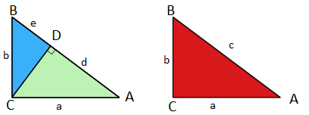
Here it is asking how the blue and green areas are related to the red area. To further the investigation we must identifying the relation between the sides of the triangles.
We know that ΔADC ~ ΔACB as they both contain a right angle and the same angle A. this is known AAA rule.
From here we know that the ratios of the sides are the same
$$\frac{AC}{AB}=\frac{AD}{AC}$$
These can be then replace with the appropriate labels from the diagram
$$\frac{a}{c}=\frac{d}{a}$$
Cross multiplying to simplify
$$a^{2}=cd$$
We can also do the same for the blue area.
ΔBDC ~ ΔBCA due to both containing a right angle and the same angle B.
Again the ratios are the same.
$$\frac{BC}{BA}=\frac{BD}{BC}$$
Replace these with variables common in the diagrams
$$\frac{b}{c}=\frac{e}{b}$$
Cross multiply to simplify
$$b^{2}=ce$$
These 2 equations can now be added together and factorised to form
$$a^{2}+b^{2}=c(d+e)$$
However d and e add to equal c
$$a^{2}+b^{2}=c^{2}$$
The green area shaded is a percentage of the area formed by a². The blue area is a percentage of the area formed by b². However due to both triangles being similar ΔACD ~ ΔCBA the sides are of the same ratio and such the percentage of the area formed by a² and b² are equal. ΔABC ~ ΔACD so now the same ruling can be applied to the red area. It also is the same percentage of c² from the other 2 sides. These percentages can be in any shape or form as long as they consist of similar triangles
$$\frac{a^{2}}{\%}+\frac{b^{2}}{\%}=\frac{c^{2}}{\%}$$

