Triangle in a Trapezium
The area of the triangle will be half the area of the trapezium.
Starting point 1
We could do the following to come up with a relation between the lengths of BC, EF and AD and also figure the heights of the two smaller trapeziums.
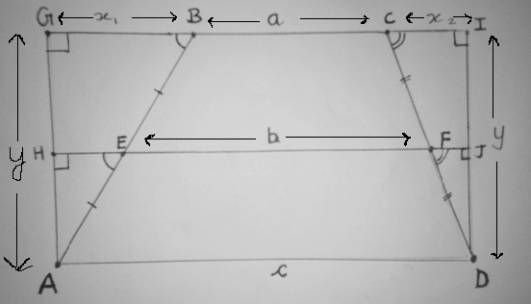
We could first assume that ‘A’ is the origin of a coordinate plane. ‘y’ in the above diagram is the height of the trapezium ABCD. According to the diagram, the coordinates of ‘B’ would be (GB, AG). Therefore GB will be perpendicular to GA as GA is the y –axis. Similarly, the coordinates of ‘E’ will be (HE , AH) and EH would be perpendicular to AH. Since angle G and angle H are equal (90$°)$ and since they also happen to be corresponding angles, we can deduce that GB is parallel to HE. This would make angle B and angle E equal.
Thus we can say that triangles AHE and AGB are similar as all their corresponding angles are equal. In addition, they will share a scale factor of 2 as AB is the double of AE. Given this, we can say that AH would be half of AG and HE would be half of GB. We can carry out the same process with triangles DIC and DJF.
So our final four equations will be...
- $\frac{AG}{2}=AH$

- $\frac{GB}{2}=HE$

- $\frac{DI}{2}=JD$

4.$\frac{CI}{2}=JF$

Since AG and DI both equal ‘y’, AH and JD, will have equal lengths(y/2) according to equations 1 and 3. Thus, even HG and JI will have equal lengths of y/2 as AH+HG=y and JD+JI=y. This would mean that the height of both trapeziums ADFE and EFCB will be y/2.

To find a relation between BC, EF and AD, we can do the following:
First we could assign variables to some line segments...
- GB=$X_{1}$
- CI=$X_{2}$
- HE=$\frac{X_{1}}{2}$
- FJ=$\frac{X_{2}}{2}$
- BC=a
- EF=b
- AD= c
- $x_{1}+x_{2}+a=c$ (from the diagram)
$→$ $x_{1}+x_{2}=c-a$
$→$ $\frac{X_{1}}{2}$ + $\frac{X_{2}}{2}$ = $\frac{c-a}{2}$
- $\frac{X_{1}}{2}$ + $\frac{X_{2}}{2}$ +$b=c$
- We can substitute equation 8 into equation 9 to give the following result:
$\frac{c-a}{2}$ $+b=c$
$→\frac{c-a}{2}-c=-b$
$→c-\left(\frac{c-a}{2}\right)=b$
$→\frac{2c-c+a}{2}=b$
$∴\frac{c+a}{2}=b$

Calculating areas:
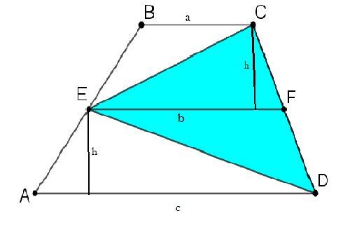
Area of the trapezium EFCB (assuming $\frac{y}{2}$ = ‘h): $\frac{h(a+b)}{2}$
Area of the triangle ECF = $\frac{bh}{2}$
Area of the trapezium AEFD =$\frac{h(b+c)}{2}$
Area of the triangle EFD (taking EF as the base) = $\frac{bh}{2}$

$∴$ Area of the trapezium ABCD = $\frac{h(a+b)}{2}$ +$\frac{ h(b+c)}{2}$
= $hb+ \frac{h(a+c)}{2}$
Substituting equation 10, we get an area of$2hb$.
Area of the triangle DEC =$\frac{bh}{2}+\frac{bh}{2}$
=$hb$

Therefore the area of the triangle ECD is half of the trapezium ABCD.

Starting point 2
To prove that the resultant figure GCDF is a parallelogram, we would have to prove that the triangles EAF and EBG are congruent.
AE=BE (as E is the midpoint of the line segment AB)
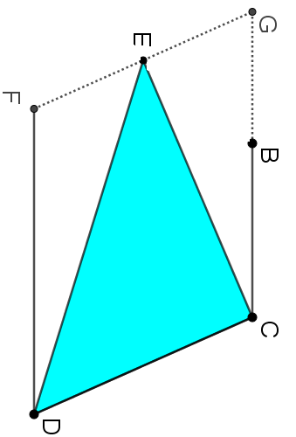
Angle GEB = Angle FEA (Vertically opposite angles)
GB and AF would be parallel as they are extensions of parallel lines. Therefore, we can say that Angle GBE = Angle FAE as they are alternate- interior angles.
$∴$ Triangle EAF is congruent to triangle EBG.
$→$Area of the trapezium is the same as the area of the parallelogram.
We can then invert the parallelogram so that the base and height of both the parallelogram and the triangle would be the same measure.
Let base be ‘b’ and let the height be ‘h’.
$∴$ Area of the parallelogram $=bh$
Area of the triangle
$$=\frac{bh}{2}$$
Since the area of the parallelogram is the same as the trapezium we can say that the triangle is half the area of the trapezium.

Starting Point 3
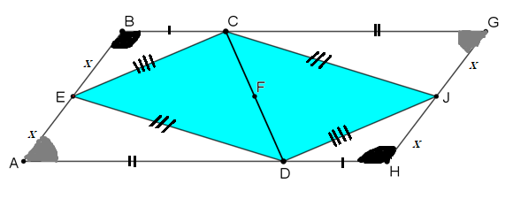From the diagram, we can tell that the line segment BG will be equal to line segment AH. They will also be parallel as opposite sides of a Trapezium are parallel. Since we have one pair of opposite sides which are parallel and equal, we can deduce that the quadrilateral ABGH is a parallelogram. As opposite angles of a parallelogram are equal, the following will hold true:
Angle B = Angle H
Angle A = Angle G
Using the SAS congruence criteria, we can say the following:
Triangle EAD is congruent to triangle JGC (Thus, line segment ED=JC)
Triangle CBE is congruent to triangle DHJ (So line segment CE=DJ).
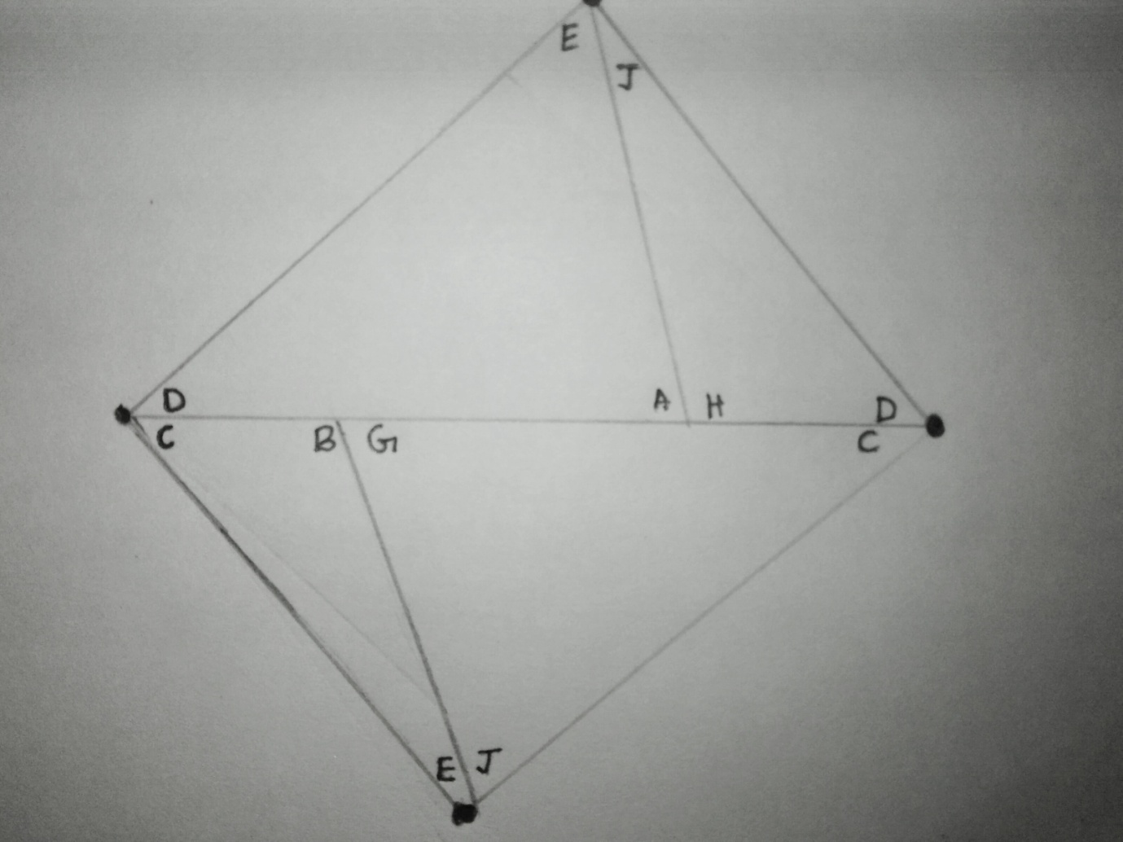
We can then rearrange triangles CBE, CGJ, AED and DHG, as shown in the image above, to form the quadrilateral DECJ (or CJDE). Since AE and HJ are of the same length ‘x’, we can join them together. Similarly as BE and GJ also share a length of ‘x’, we can join them together. As proved earlier, triangle EAD is congruent to triangle JGC and triangle CBE is congruent to triangle DHJ so the bases will be the same, in which case we can join them to form the quadrilateral DECJ. This is identical to the two triangles contained in the trapezium, put together. Therefore, we can say that the area of the quadrilateral DECJ is half the area of the parallelogram BGHA. As the parallelogram is just 2 copies of the trapezium, we can say that the area of CED is half of that of the trapezium ABCD.

