Triangle in a Trapezium

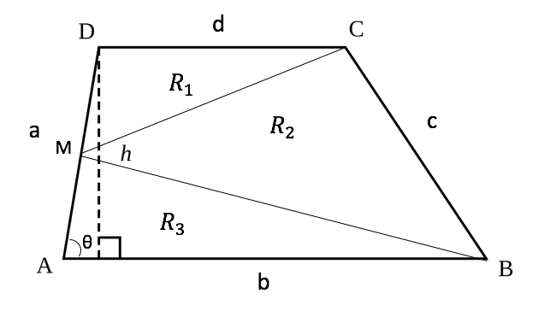

$$Area of Trapezium: A= \frac{h (b+d)}{2}$$
$$h=a\sin{θ}$$
$$A= \frac{ a\sin{θ}(b+d)}{2}$$
$$R_{1}+R_{2}+R_{3}= \frac{ a\sin{θ}(b+d)}{2} (*)$$
$$R_{3}= \frac{1}{2}\left(\frac{a}{2}\right)b\sin{θ }$$
$$R_{3}= \frac{ab}{4}\sin{θ }$$
<ADC = $π-θ$ as b and d are parallel.
$$R_{1}= \frac{1}{2}\left(\frac{a}{2}\right)d\sin{(π-θ)}$$
$$\sin{(π-θ)}= \sin{θ}$$
$$R_{1}= \frac{ad}{4}\sin{(θ)}$$
Using equation $\left(*\right),$
$$R_{2}= \frac{ a\sin{θ}(b+d)}{2} - R_{1}-R_{3}$$

$$R_{2}= \frac{ a\sin{θ}(b+d)}{2} -\frac{ad}{4}\sin{(θ)} -\frac{ab}{4}\sin{θ }$$
$$R_{2}= \frac{a\sin{θ}}{2}\left(b+d-\frac{1}{2}(b+d)\right)$$
$$R_{2}= \frac{a\sin{θ\left(b+d\right)}}{4}$$
$$R_{2}= \frac{A}{2}$$
Therefore, the area of the triangle in the trapezium ($R_{2})$ is half of the area of the trapezium.

