First, I put all of the 16 counters to fill the grid and checked how many squares there were.
Then I tried to pick counters that can break up the most squares with each counter taken away.

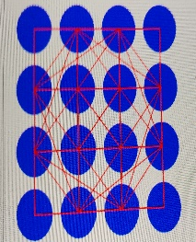
Next, I took out one corner counter, which broke up 3 squares – 1 big one, 1 middle sized square, and also 1 small square.

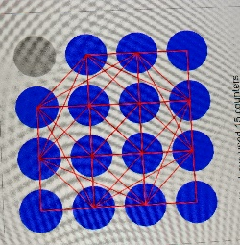
Then, I took out another counter near the middle, because it would break up 4 small squares, 1 diamond shaped square and 1 middle sized square.

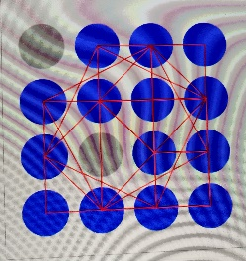
Then, I removed another counter close to the middle, that broke up 3 small squares and 1 middle sized square.
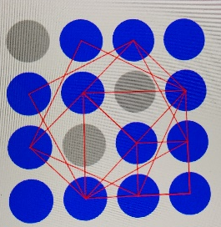
After that, I removed another counter close to the middle, which broke up 1 small square and 2 diamond squares. There were 3 squares left.
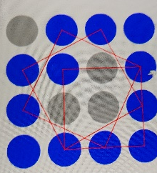
Next, I removed 1 counter on the bottom row, which broke up 1 middle sized and 1 middle size diamond square. Now there is 1 left.

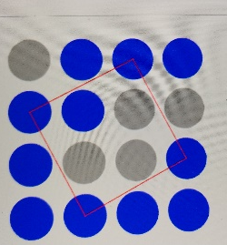
Finally, I removed one counter of this diamond ( you can actually choose any corner of the diamond for it to work ) to break up the last square.



