Nrich Solution Factor Lines 1138

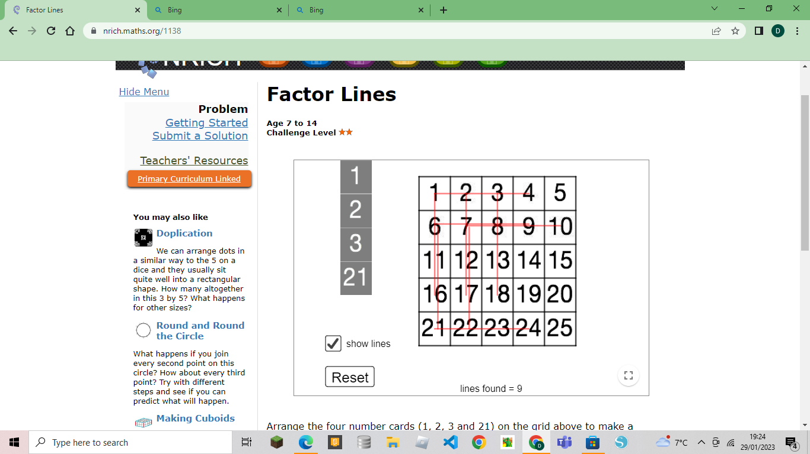
When I tried all the ways these are the ones I got,
1 – 16
21 – 6
1 – 4
2 – 17
22 – 7
21 – 24
6 – 9
10 - 7
1 – 4
3 – 18.
The trick I used was I knew that 21 could not have had any multiples in a 5 x 5 table, so I worked out all the factors of 21 and started every line from there. The factors of 21 are 1, 3, 7 and 21, that’s why every line starts from these numbers.
For numbers like 6 and 12 I could have put 1, 2 or 3 because 6 and 12 are multiples of these numbers but I had to think carefully as some of the numbers (in the lines) could only be multiples of 3 or 2.
I ended up with 9 lines and could not make any more.

