The first thing to note is that the graph is of an odd function – it has rotational symmetry order two about the origin. This allows us to assume symmetry when considering roots and vertical asymptotes.
We can see that there are three roots. One is at $x=0$, and the two others occur at $x=±a$, where $a$ is a positive real number. This information tells us about the numerator of a potential function, since roots will occur when the numerator is equal to zero. For the root at $x=0$, a factor of $x$ in the numerator will suffice. For $x=a$ and $x=-a$, factors of $(x-a)$ and $(x+a)$ respectively will give roots at the correct $x$-values. In order to make the solution as general as possible, a multiplier should also be included in the numerator in order to encompass a wider family of possible functions without affecting the validity of the roots themselves.
Due to the rotational symmetry, we can say that the $x$-values of the two vertical asymptotes are equal in magnitude in a similar way to the non-zero roots. We can say that they occur at $x=±b$, where $b$ is again some positive real number, which should be slightly smaller than $a$, according to the graph. Vertical asymptotes occur when the denominator of a function is equal to zero. This can be achieved in this case by putting the factors $(x-b)$ and $(x+b)$ in the denominator of a potential function.
So far, then, we have
$$y=\frac{cx(x-a)(x+a)}{(x-b)(x+b)}=\frac{cx(x^{2}-a^{2})}{x^{2}-b^{2}}$$
The final property of the graph that is yet to be examined is its linear asymptote that is neither vertical nor horizontal. We can say that is of the form $y=kx$. Let’s look back at the function in progress. As $x→∞$, the constant terms become insignificant, so
$$y≈\frac{{cx}^{3}}{x^{2}}≈cx$$
In other words, the asymptote obeys the relationship $y=kx$ where $k=c$.
So, the equation of the graph will be of the form
$$y=\frac{cx(x^{2}-a^{2})}{x^{2}-b^{2}}$$
Where $a,$ $b$ and $c$ are positive real constants and $a>b$.
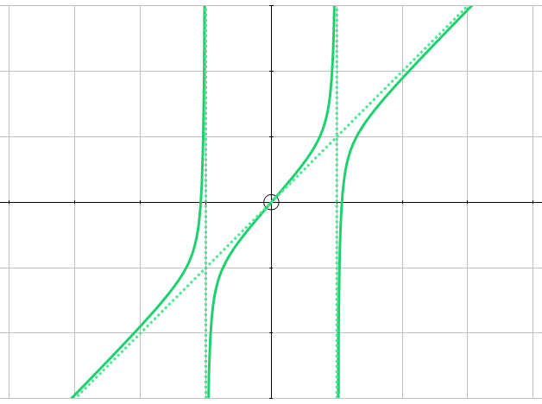
The above graph is an example for $a=1.08$, $b=c=1$.
Other Observations
The middle section of the graph bears some resemblance to trigonometric and hyperbolic functions such as $y=tan(x)$ and $y=artanh(x)$. There are obvious problems with each of these. The latter’s domain is $-1<x<1$, which would make it very difficult to produce a function defined over all real $x$, which we see in the graph (vertical asymptotes aside). This could be achieved by taking the inverse hyperbolic tangent of a function which have ranges limited to $-1≤f\left(x\right)≤1$ – sine and cosine spring immediately to mind. Nonetheless, this presents a new problem, periodicity, which we also encounter with the tangent function mentioned above. In this case, progress could be made by limiting the domain. Variations on $y=x+tan(x)$ are particularly effective. Below is an example of such a function, $y=2x+tan\left(\frac{x}{2}\right)$:
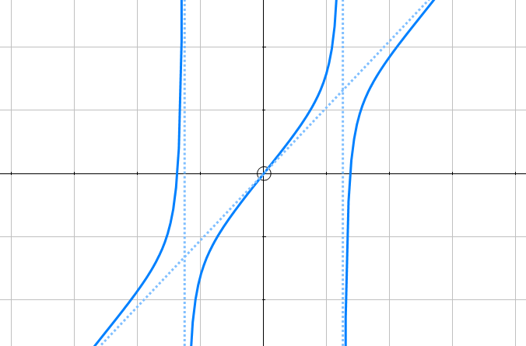
Although various aspects of this idea are clearly problematic, it is interesting nonetheless that a shape so similar to the one sought after can be achieved through an entirely different approach.

