The first thing I did was deciding on a mode. If the mode needed to be the highest value then the highest two numbers have to be the same. If the mode had to be the lowest then the lowest two numbers would have to be the same. If the middle value is the mode in a sequence with 5 or less numbers in it then it cannot be completed. This is because the mode would be the same as the median therefore making them equal rather than bigger/smaller.
If we wanted a large mean we would stick a large number at the end. If we wanted a small mean we would stick a small number at the end. Once again if we wanted a mean in the middle then we would stick a number somewhere in the middle.
If we wanted a small mode and median we would put a mode of 1 and then only go up by 1 for the next digit. Resulting in the pattern being 1,1,2 .If we wanted the median to be high we would go up a considerable amount like 10 so the pattern would be 1,1,11 .
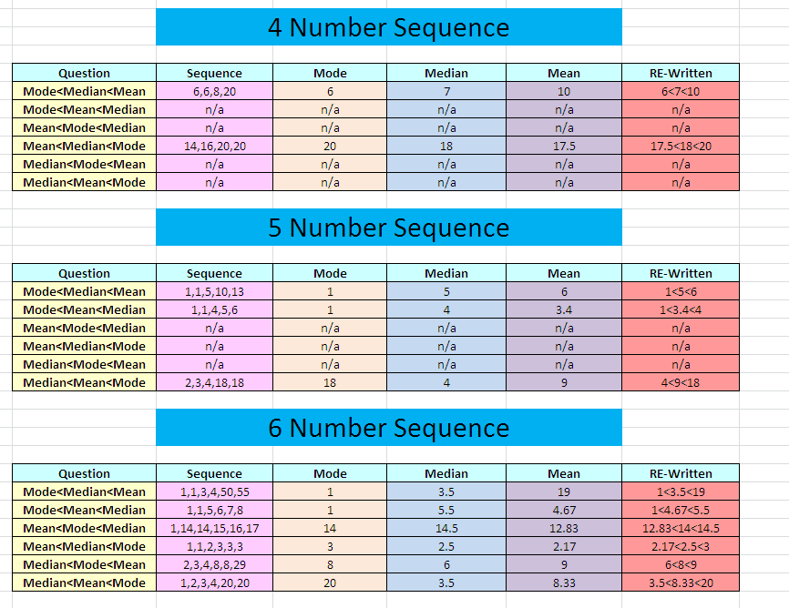
By Thomas and Jamie
Our problem was to determine a set of 5 integers that apply to the questions at hand . In this presentation you will be showed our solutions and answers to Unequal Averages .
Unequal Averages

