Hollow Squares

Stage: 4

How could you quickly work out the number of dots in each?
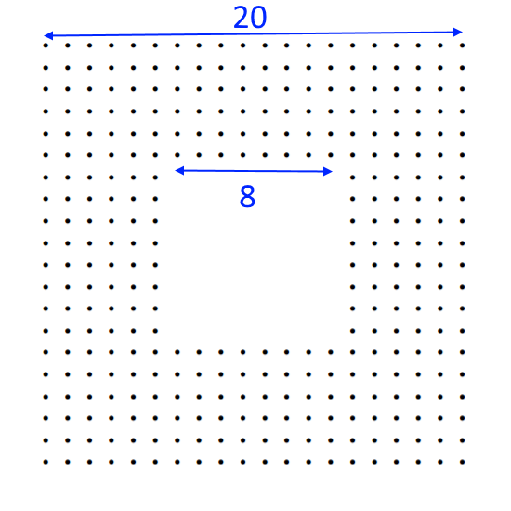
Difference of two squares = (a+b)(a-b) = (28)(12) = 336
A general has 960 soldiers. How many different ways can he arrange his battalion in a symmetric hollow square?
How many differences of two squares equal 960?

A = 31, B = 14
A = 38, B = 22
A = 46, B = 34
A = 53, B = 43
A = 64, B = 56
A = 83, B = 77
A = 122, B = 118
A = 241, B = 239
What can you say about battalion sizes that can't be arranged as symmetric hollow squares?

They are not the difference of two squares.
Can you find a general strategy for arranging any possible battalion into all possible symmetric hollow squares?
Trial and improvement with the difference of two squares.
What about hollow squares that are not symmetric...?

Not sure!

