Solution to Hollow Squares
Question 1:
The way to find out x in the screenshot below is to take away 8 from 20 which leaves you 12. There are equal number of soldiers on either side so 12 divided by 2 equals to 6. So 6 times 6 equals is 36. There are 4 of those little squares so 36 times 4 equals to 144. To find out y in the screenshot, there is 7 across left after finding out x. So 7 times 8 equals 56. There are 4 of those rectangles so 56 times 4 equals to 224. To find out the total number of soldiers in the battalion, add up 244 and 144. The answer is 368.
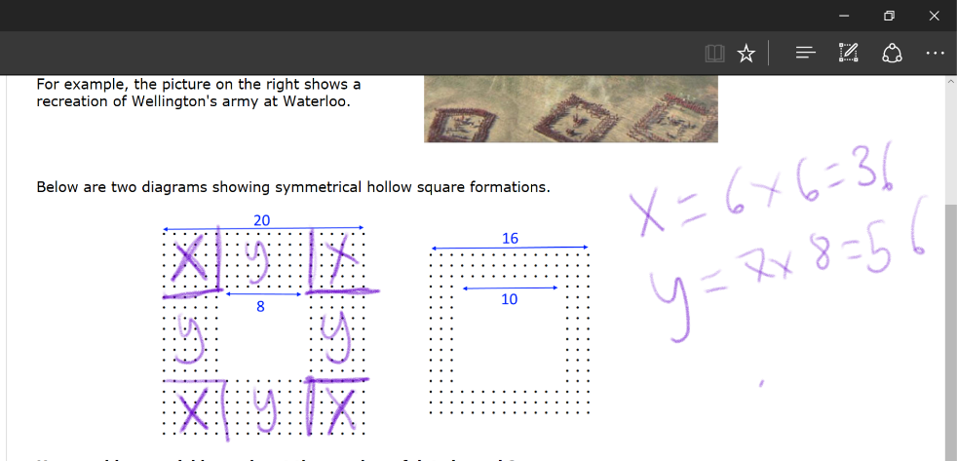
Question 2:
There are 10 ways to make a battalion with a hollow square. Firstly, I divided the hollow square battalion into 4 equal parts. So, 960 divided by 4 equals to 240. The following multiplications are the only ways to make 240 thus 960 as well:
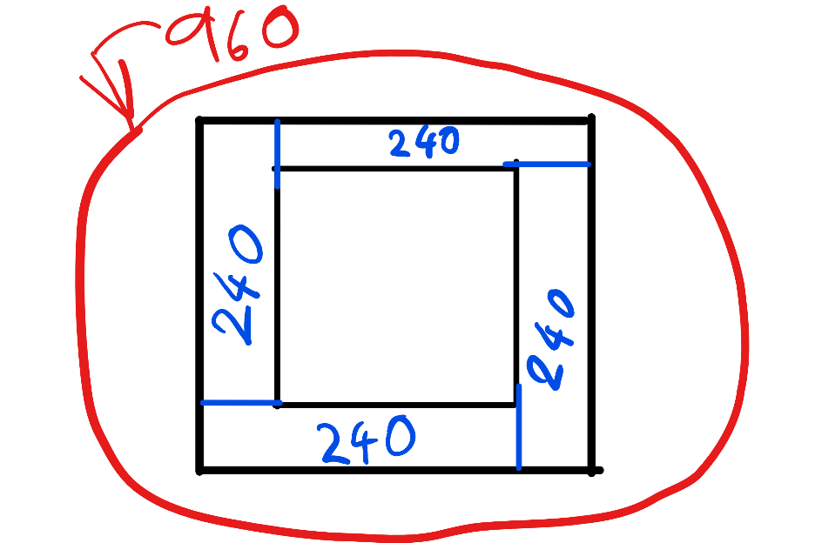
1*240
2*120
3*80
4*60
5*48
6*40
8*30
10*24
12*20
15*16
Therefore, there are ten ways to make the battalion.
Question 3:
The strategy used in the answer above is a general strategy to arrange any possible battalion into hollow squares.

