Which polygons can make rings around a shape which uses only 1 side of each polygon?


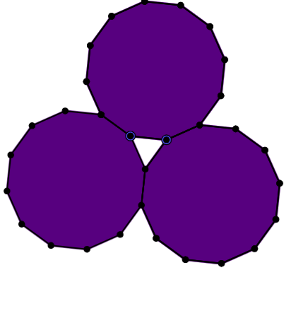
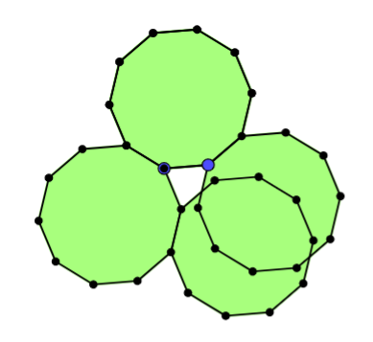
All even sided polygons except the decagon can make a ring with only one side of each polygon used.
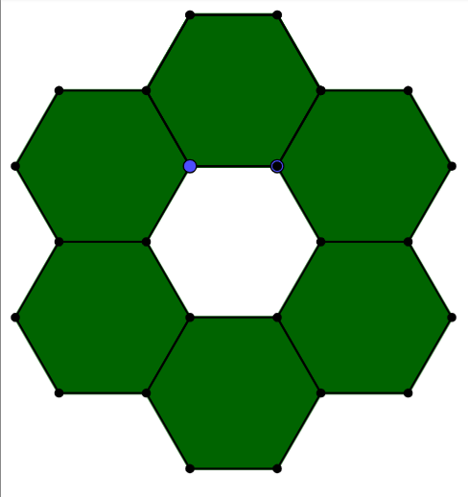

Decagon Tetragon Dodecagon Hexagon

However, this isn’t a definitive answer as i can’t look at farther shapes, and also the pentagon is also able to make a circle with only one side making up the interior shape.
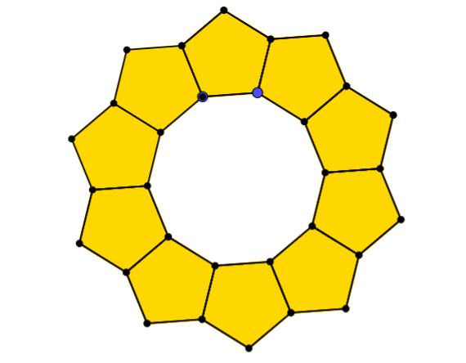

Other shapes all overlap.

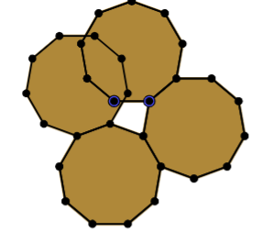

While I couldn’t come Up with a 100% full proof rule , my conclusion Is that all even sided polygons are able to make a ring around a shape which uses only 1 side of each polygon, apart from the pentagon and decagon, apart from those, this rule seems persistent as all of the polygons that do work are:

4-gon 5-gon 6-gon 8-gon 12-gon

