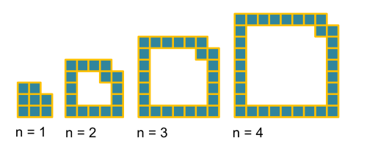
For simplicity’s sake, I will refer to the first sequence as A and the second as B, with A_{n} referring to the n^{th} term of A. In sequence A, each shape consists of two 2n - 1 sides and two 2n + 1 sides (counting the inverted square as part of the top line).

This gives us the formula 2(2n - 1) + 2(2n + 1), simplifying to give 8n. Non-visually, we could have got this result by noting the difference between the terms given (8, 16, 24, 32) to get 8.
Interestingly, if we fit the pieces into each other, we get the solid shapes shown in sequence B:

So, looking at the fourth shape, A₁ + A₂ + A₃ + A₄ = B₄

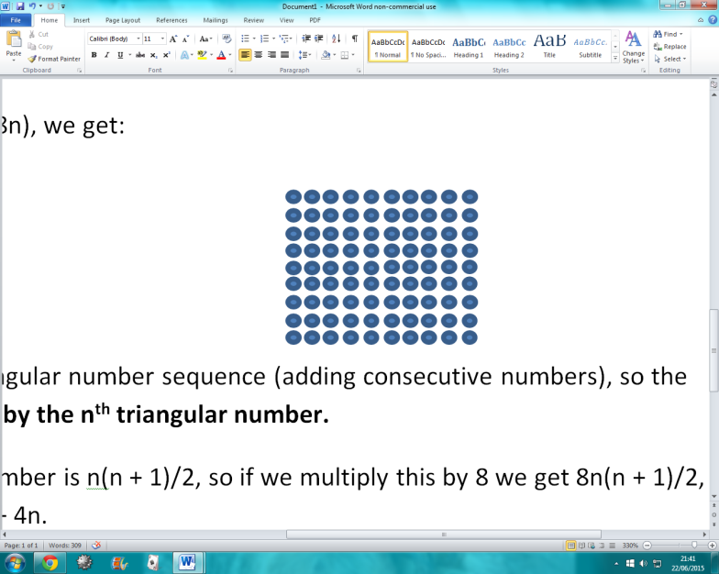
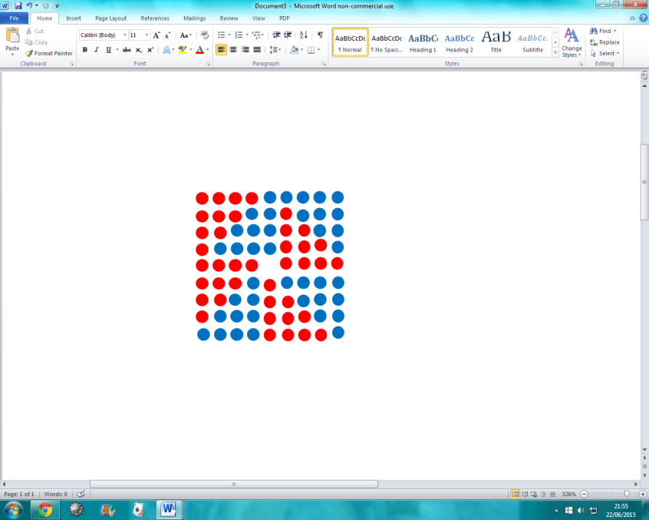
Generally, B_{n} = A_{n} + A_{n-1} … + A₁
B₄
4th triangular number
8 x 4th triangular number- notice the gap in the middle, which in the 4th term of B, above, would be in the top right corner
Using the equation for sequence A (8n), we get:
B_{n} = 8n + 8(n - 1) … + 8(1)
or, B_{n} = 8(n + (n-1)… + 1)

We should recognise this as the triangular number sequence (adding consecutive numbers), so the n^{th} term in B is equal to 8 multiplied by the n^{th} triangular number.
The formula for the n^{th} triangular number is n(n + 1)/2, so if we multiply this by 8 we get 8n(n + 1)/2, which simplifies to 4n(n + 1), or 4n² + 4n. To check that this is the formula for the n^{th} term of B, we can find the first and second differences of the sequence.

We can then half the second difference, 8, to see that the first part of the formula is 4n². Comparing this new sequence (4, 16, 36, 64) to our original one gives a difference of 4n. Combined, the formula for the n^{th} term of sequence B is 4n² + 4n- just as we predicted.
8 24 48 80
16 24 32
8 8

