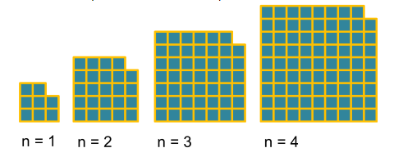
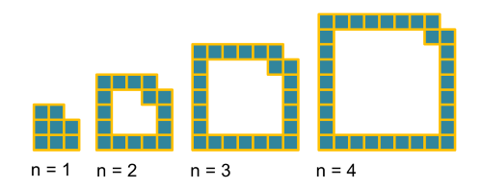
Here is the connection between the two answers:

The first formula is Un=8n which can be factorised into 4n(2).
The second formula is Un=(2n+1)²-1 which follows this expansion:

Un = (2n+1)²-1
Un = (2n+1)(2n+1)-1
Un = 4n²+2n+2n+1-1
Un = 4n²+4n

This is re-factorised into Un =4n(n+1)

Both formulas are a factor of 4n.

20th term = 8(20)
=160
The square pattern of 3,5,7,9,11 is 9,25,49,81,121

The numbers of squares in the shapes are one less than these numbers. The number added to n is n+1. This means that

Un=(2n+1)² - 1

20th term = (2(20)+1)² - 1
=1680
120
80
48
24
8
n=5
Un = 8n
40
32
24
16
8
n=5

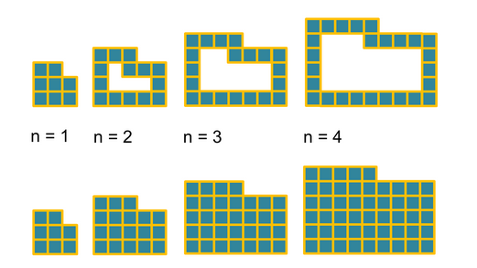
26
20
14
8
50
32
18
8
The two separated halves are both the same. In this case they are 3 by 4.
2 x 3 x 4 is the area of y

so: y = 2n(n-1)
x is just 6n+2.

The 4th term for x is the two formulae added together.

This means Un = (2n(n-1)) + (6n+2)
Un = 2n²-2n+6n+2
Un = 2n²+4n+2
= 50

20th term = (2(20)(20-1)) + (6(20)+2)
= 882

The smaller one which is n(in this case y)=4 fits into n(in this case x)=3. To find the area y you would half x and subtract the extra squares.
The two sequences are linked; finding a way to solve the second sequence involves the first one.
Look at the diagram below.
It goes up by six each time and is 2 above the 6 times table.

Un= 6n+2
2nd term = 6(2)+2
=14

20th term= 6(20)+2
= 122

