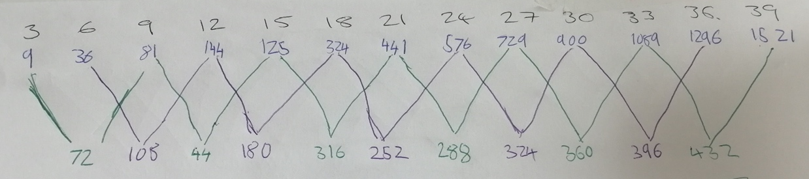

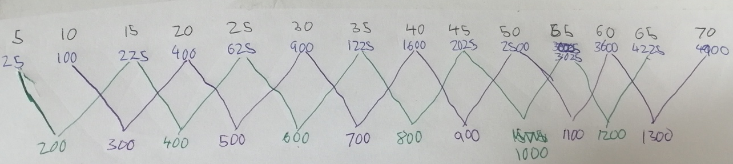
For the three times table I noticed that for the resulting number, the last digit repeated this pattern: 2, 8, 4, 0, 6.

For the five times table I noticed 2 things, one of them being that the resulting number went up by 100 each time. The other one being that they all ended in 0.

