(a) 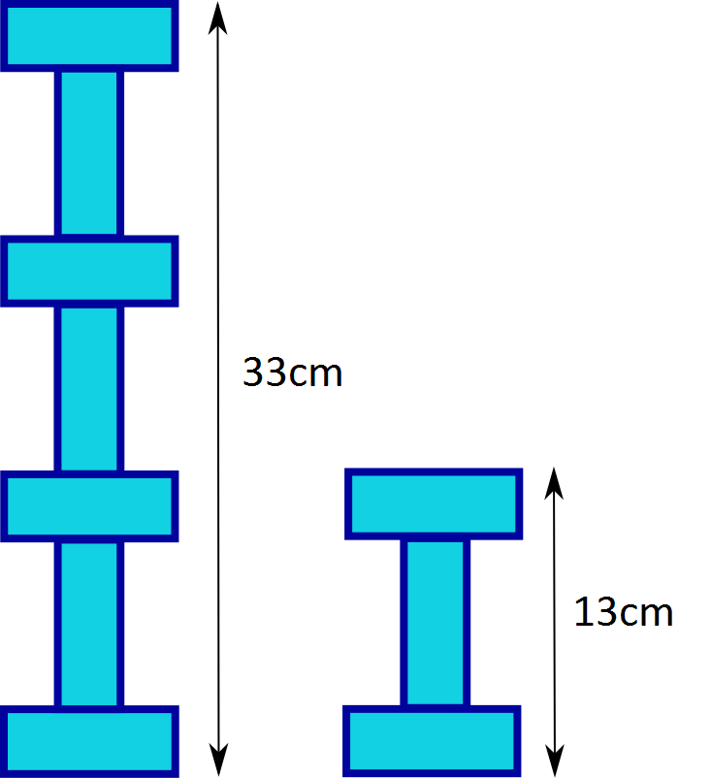
L=length W=width
20cm
3L+4W=33cm
2L=2W=20cm
L+W=10cm
3L+3W=30cm
Width of rectangle=3cm
W*4= 12cm
33cm-12cm=3L SO… 3L=21cm
3L/3=L Which is 21cm/3=7
Length of rectangle=7cm
Perimeter=20cm
(b)

L*(W+W+L)=60cm which is the area.
60cm/5(is the amount of squares) = 12cm which is the area of one individual square.
So the W=3 L=4 OR W=6 L=2 OR W=4 L=3 OR W=2 L=6 OR L=12 W=1 OR L=1 W=12
Using trial and error I found out that its must be W=2 L=6 because 6*(2+2+6) = 60cm
Width=10cm (2+2+6)

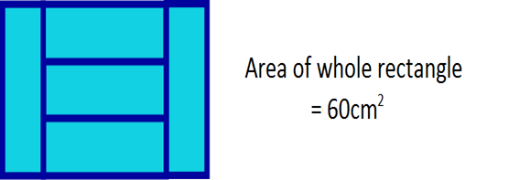
Length=6cm
So the messuremnts of the rectangle= width=2cm length=6cm
perimter=16cm.

