Perimeter Challenge

(a)

One Side: x
Other Side: y

4x + 3y = 33 – >(1)
2x +y =13 –>(2)

3 * (2)-(1)=
2x =6
x=3
y=7
Therefore, the perimeter is 20cm

(b)

One Side: x
Other Side: y

(2x +y)*y=60
5xy=60

(2x+y)*y=5xy
y^2=3xy
y=3x
Substitute 3x into y
5x*(3x)=15x^2=60
x^2=4
x=2
y=6
Therefore, the perimeter is 16cm

(c)

One Side: x
Other Side: y

(2x+y)*y=600
2xy+y^2=600
6xy=600
2xy=200
200+y^2=600
y^2=400
y=20mm(2cm)
x=50mm(5cm)

Perimeter is 14cm
(d)

One side: x
Other side: y

5x*(x+y) =180
5x^2+5xy=180
9xy=180
xy=20
5x^2+100=180
5x^2=80
x^2=16
x=4
y=5
Therefore, the perimeter is 18cm

Last Yellow Diagram:
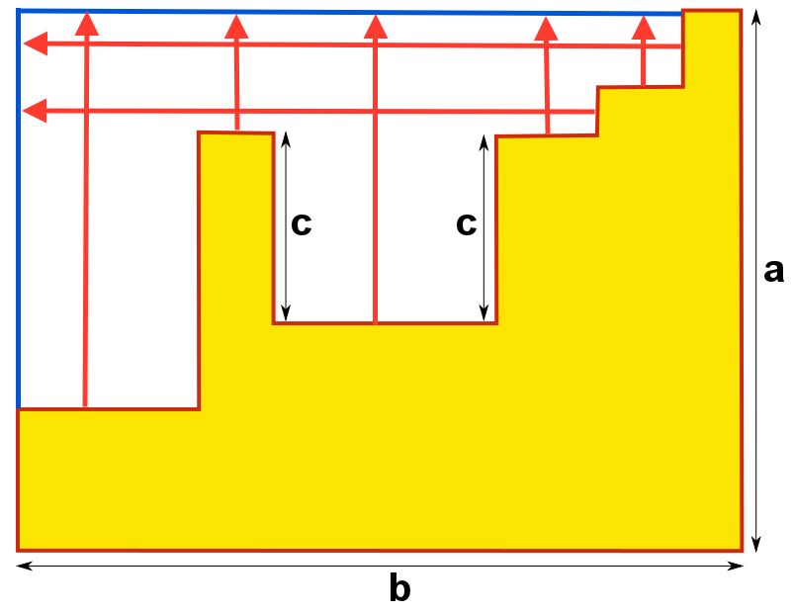
The extended red lines form the perimeter of the rectangle, which is 2ab
However, the c in the middle cannot be extended as part of the perimeter so they have to be added separately
Therefore, the whole perimeter is 2ab+2c, which is 2(ab+c)

