“Perimeter Challenge”

- The perimeter of one of the small rectangles is 20cm
Length = L
Width = W

We know from the diagrams given that L + 2W=13cm

We also know that 4W + 3L = 33cm

2L+ 4W = 13*2 = 26 cm

if 2L+ 4W = 26 and 4W + 3L = 33 then L = the difference between 26 and 33 which is 7.

If L = 7 then 7 plus 2W = 13

2w = 13-7

2w = 6

W = 6/2

W = 3

The perimeter of the rectangles = 2*3 + 2*7
= 6 + 14
= 20
The units are cm, therefore the perimeter of each rectangle = 20 cm

- The perimeter of each rectangle = 16 cm

From the diagram given we are told that the area of the entire rectangle = 60 cm² and can see it is made up of 5 identical rectangles.

60 / 5 = 12, therefore the area of each rectangle = 12cm²

This means the width and length of each rectangle must have a product of 12.

From the diagram we know the entire area of all of the rectangles= 60 cm² and again from the diagram, we learn this equals: (2*width +the length) *the length.

This means the length and width multiplied together must equate to 12, but the length x the length+2*width must = 60

There is only one solution for this so we first must consider a sensible factor pair of 12 that could be our width and length.

The width is approximately 3 x smaller than the length; therefore the factor pair could be 2 and 6. 2x6 = 12

If the width = 2cm because it is smaller than the length and the length = 6 cm then the area of the rectangles does equate to 12 cm² as it should. The area = the width x the length = 2 x 6 = 12

We then must check if these numbers work in the equation (2*width +the length) *the length = 60cm².

2*width = 2 x 2 = 4

4 plus the length of 6 = 10

and 10 x the length = 10 x 6 which = 60.

This shows that the width of each rectangle = 2 and the length = 6

The perimeter is 2x length + 2x width
which = 2 x 6 + 2 x 2
= 12 + 4
=16

The units are cm, therefore the perimeter of each rectangle = 16 cm

c) The perimeter of each rectangle = 50mm

From the diagram given we are told the area of the entire rectangle = 600mm² and can see that it is made up of 6 identical rectangles.

600 / 6 = 100, therefore the area of each rectangle = 100 mm²

This means the width and length of each rectangle must have a product of 100.

From the diagram provided we know the entire area of all of the rectangles = 600mm² and again from the diagram, we learn this equals: (2*width +the length) *the length.

This means the length and width multiplied together must equate to 100, but the length x the length+2*width must = 60

There is again only one solution for this so we first must consider a sensible factor pair of 100 that could be our width and length.

The width is approximately 4 x smaller than the length; therefore the factor pair could be 5 and 20. 5x20= 100

If the width = 5mm because it is smaller than the length and the length = 20 mm then the area of the rectangles does equate to 100 mm² as it should. The area = the width x the length = 5 x 20 = 100

We then must check if these numbers work in the equation (2*width +the length) *the length = 600mm².

2*width = 2 x 5 = 10

10 plus the length of 20 = 30

and 30 x by the length = 30 x 20 which = 600

This shows that the width of each rectangle = 2 and the length = 6

The perimeter is 2 x length + 2 x width
Which = 2 x 20 + 2 x 5
= 40 + 10
=50

The units are mm, therefore the perimeter of each rectangle = 50mm.

- The perimeter of one of the rectangles = 58cm

From the diagram given we are told the area of the entire rectangle = 180cm² and can see that it is made up of 9 identical rectangles.

180 / 9 = 20, therefore the area of each rectangle = 20 cm²

This means the width and length of each rectangle must have a product of 20.

From the diagram we know the entire area of all the rectangles = 180 cm². If we say the shorter side is the width and the longer side of the rectangle is the length then again from the diagram, we learn 180 cm² =(width +the length) * 5x width.

This means the length and width multiplied together must equate to 20, but also that the (width + the length) * 5x width must = 180

There is again only one solution for this so we first must consider a sensible factor pair of 20 that could be our width and length.

The width is almost the same size as the length but only a little bit shorter therefore the factor pair could be 5 and 4. 5x4= 20

If the width = 4 because it is smaller than the length and the length = 5 then the area of the rectangles does equate to 20 cm² as it should. The area = the width x the length = 4 x 5 = 20

We then must check if these numbers work in the equation (width + the length) * 5x width = 180

Width = 4

4 plus the length of 5 = 9

5 x by the length = 5 x 4 which = 20

20 x 9 does = 180

This shows that the width of each rectangle = 4 and the length = 5

The perimeter is 2 x length + 2 x width
Which = 2 x 5 + 2 x 4
= 10 + 8
=18

The units are cm, therefore the perimeter of each rectangle = 18 cm

- The perimeter of the shape = 2 a + 2c + 2b

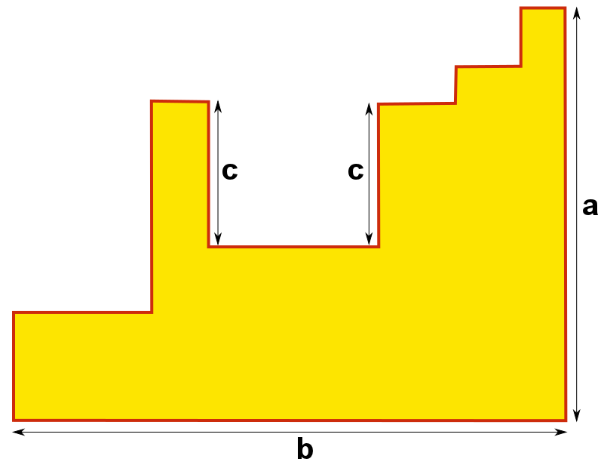

From this diagram we know the perimeter includes the addition of at least 1a, 1b and 2c.

If we ignore the 2 lines that are labelled c and the line a, we are left with 4 vertical lines that are shown on the diagram above with blue diagonal lines. Due to the fact these four lines are vertical and do not overlap their total length is the equivalent to a. If you placed these four lines directly one above the each other, their length would equal a.

So we now know the perimeter = at least 2 a, 1b and 2c.

If we now only focus on the horizontal lines, ignoring the line B, we are left with 6 lines, which are shown by the red curvy lines. However, these lines again follow on from the previous horizontal line, just not on the same level as it. This means these 5 horizontal lines left (marked by the red curvy line) equal to the length of B.

This means the total perimeter of the shape involves the addition of another b.

Therefore, the total perimeter of this shape = 2b + 2c + 2a.

