Year 10 Hautlieu School

We worked on the problem as a class, in pairs and with our tables.
We started by trying numbers and seeing if we could find something that worked.

After a while some people got:

4 | 5
5 | 5
As some of us thought that using lots of 5’s would work.
Then some more people got:

0 | 9
9 | 1

2 | 7
7 | 3

And a few more were found where the top left grid square had the numbers 0 to 8 in.

Our teacher then asked if we could make one with:

9 | b
a | c

And some of us then thought about what we needed for this:

90+b+90+a+10a+10b+2c = 200
11a+11b+2c = 20
11(a+b)+2c =20

We needed an even multiple of 11, but that would be 22 as the smallest. So, this wouldn’t work.

After this some of us wrote things like this after noticing the answer we found and the ones that were found that didn’t work:

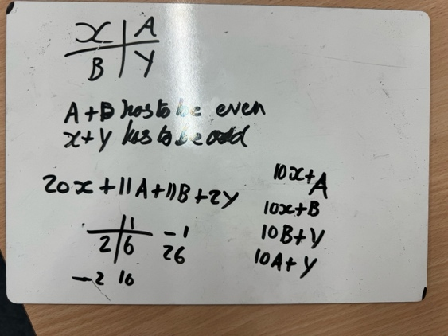

After this it was then obvious that 11(A+B) meant that A+B needed to be even as 20x, 2Y and 200 are even.

We then all worked on fixing the top left number as 0, 1, …, 8 and looking for even multiples of 11 that the Y would be a number from 0 to 8 which makes 11(A+B) + 2Y = 200 – 20X work.

This gave us this,

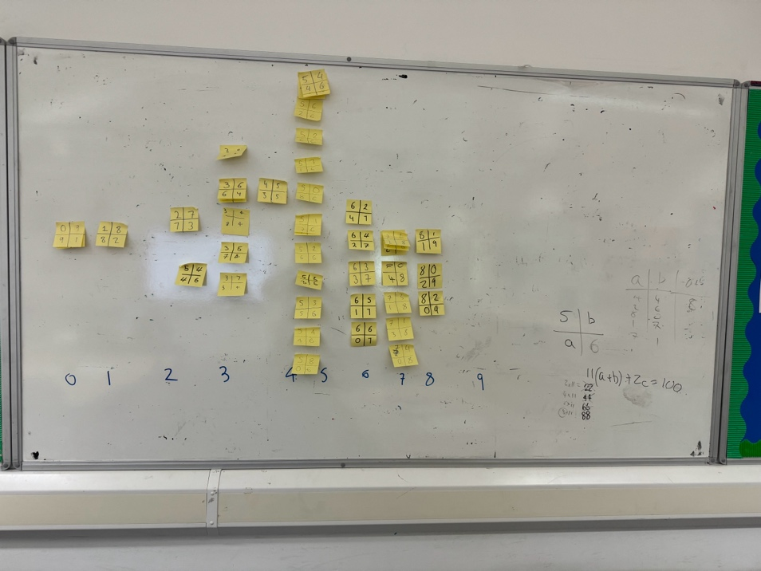

Which isn’t complete but our lesson ended! And we knew what the idea was that would fill out the rest.

For example for 5 in the top left corner, we noticed that 20*5+11(A+B)+2Y=200.
We needed 11(A+B)+2Y=100. The even multiples of 11 close to 100 are 88 and 66, but 66 is too far away (Y would need to be 17 which it cannot be).

11*8+2Y=100, so Y=6. This gave us:

5 | B
A | 6

Where A+B=8.

A | B
0 | 8
8 | 0
1 | 7
7 | 1
2 | 6
6 | 2
3 | 5
5 | 3
4 | 4

And this gave all the possibilities for 5 in the top left hand corner.

Someone of us started this by thinking the question was really hard and even impossible, but it clearly is possible and once we saw what we needed with the even multiples of 11s it became very doable.

