A Solution to ‘Quadrilaterals in a Square’
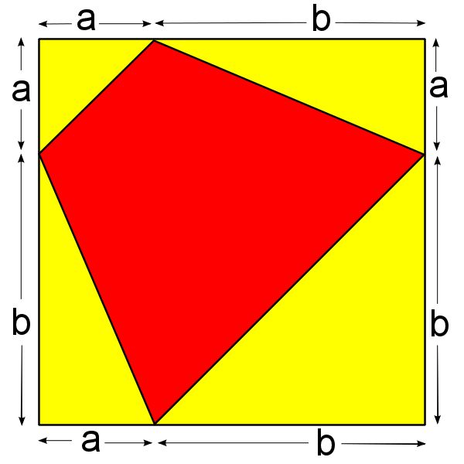
The first part
Algebraic: The total area of the square is (a+b)² = a² + b² + 2ab. Now, consider the ‘outside’ area of the square. We can divide this into 4 yellow triangles. Note that all of these contain a right angle, and so we can use the ½bh formula.
Triangle 1: 1/2 x a x a = a²/2
Triangle 2: ½ x a x b = 0.5ab
Triangle 3: ½ x b x b = b²/2
Triangle 4: ½ x b x a = 0.5ab
Overall ‘yellow’ area: (a²+b²)/2 + ab = ½( a² + b² + 2ab)
The yellow area is half of the total area, therefore the red area also equals half of the total area.
1
2
3
4

Geometric: Consider the ‘rectangles’ which have area a², b², ab and ab. Each red triangle is equal to exactly half of the area of its respective rectangle/square. Therefore the area of the red shape is half the area of the whole shape.

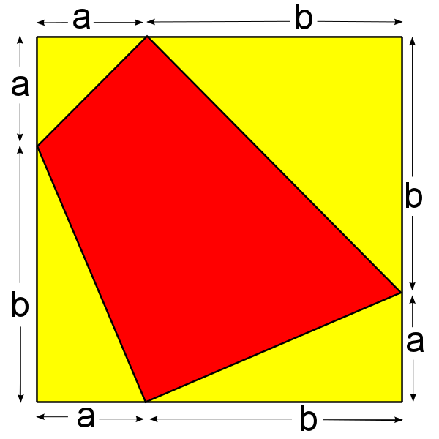

Geometric: Similar to the last problem, the square can be divided into two rectangles and two squares. The two squares have area a² and b² and two rectangles which have a combined area of 2ab. For all cases, the red area is exactly half of the total sub-area. Therefore the red area is half the total area of the square.
Algebraic: Here, the total area is a² + b² + 2ab. Again, with the last problem, we can find the area of the ‘yellow’ triangles since they are all right-angled. Also, again, the areas of these four triangles total (a²+b²)/2 + ab = ½(a² + b² + 2ab). Therefore the area of the yellow area, and therefore the red area, is ½ of the total area.

The second part
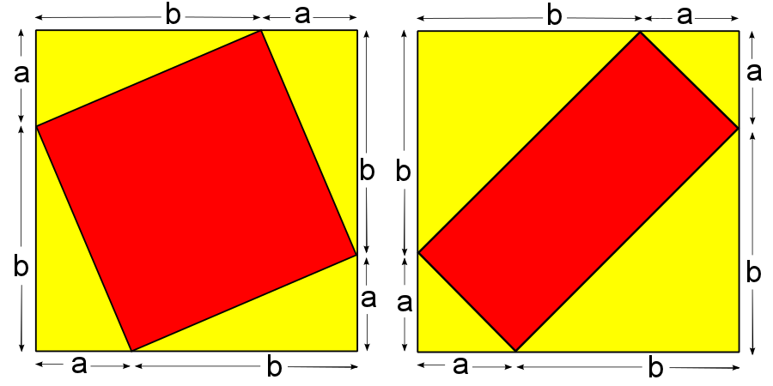
The proof: First, note that if the two red areas sum to the area of a single square, the two yellow areas will as well (since they both must sum to the area of two squares).
With this information, we can solve this problem:
Area of Triangle 1: ½ x a x b =( 1/2)ab
“ 2: ½ x a x b = (1/2)ab
“ 3: ½ x a x b = (1/2)ab
“ 4: ½ x a x b = (1/2)ab
“ 5: ½ x b x b = (1/2)b²
“ 6: ½ x a x a = (1/2)a²
“ 7: ½ x a x a = (1/2)a²
“ 8: ½ x b x b = (1/2)b²
Total ‘yellow’ area: a²+b²+2ab
Therefore total ‘red’ area: a²+b²+2ab.
This is exactly the area of a single square.

Geometric: consider the rightmost diagram. Now, the area of the red area is a$\sqrt{2}×b√2=2ab$. We can split this into four segments of area( ½)ab which have the exact same shape as the ‘yellow’ triangles in the leftmost triangle. Therefore we can reshuffle the shapes so that one square is completely red and the other is completely yellow. This proves the original statement.
7
8
6
5
4
3
2
1

