Fractions in a Box
Submitted by Hamish (10yrs), Rory (10yrs), Sarah (9yrs), Jesse (10yrs) & Samuel (8yrs)
First we realised that the booklet had to cover a square number.
1 4 9 16 25 36 49
Then we took out the odd ones, because you couldn’t split them in half (red)
4 16 36
Then we had to check if these numbers could be split into halves, quarters and twelfths evenly by using division sums.
This knocked out 36, so we trialled the other two.
When we tried the booklet size being 2 x 2, the number of counters needed couldn’t work (we needed at least three short rows to make it work.
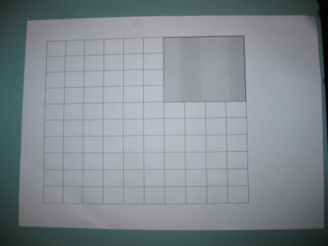
Once we knew the booklet size had to be 16 squares in
area, we had 84 discs to work with.

One shortened row had to be orange (6)
Half the discs had to be red (42 – two short rows and three long)
One row had to include the blues (7) and all the greens (3)
Next we did the blacks (21-two long rows and one of the blacks had to be on the next short row)
After that we did the whites (1)
Then we knew that we had to fill the rest in yellow (4)

