Triangles in a Square
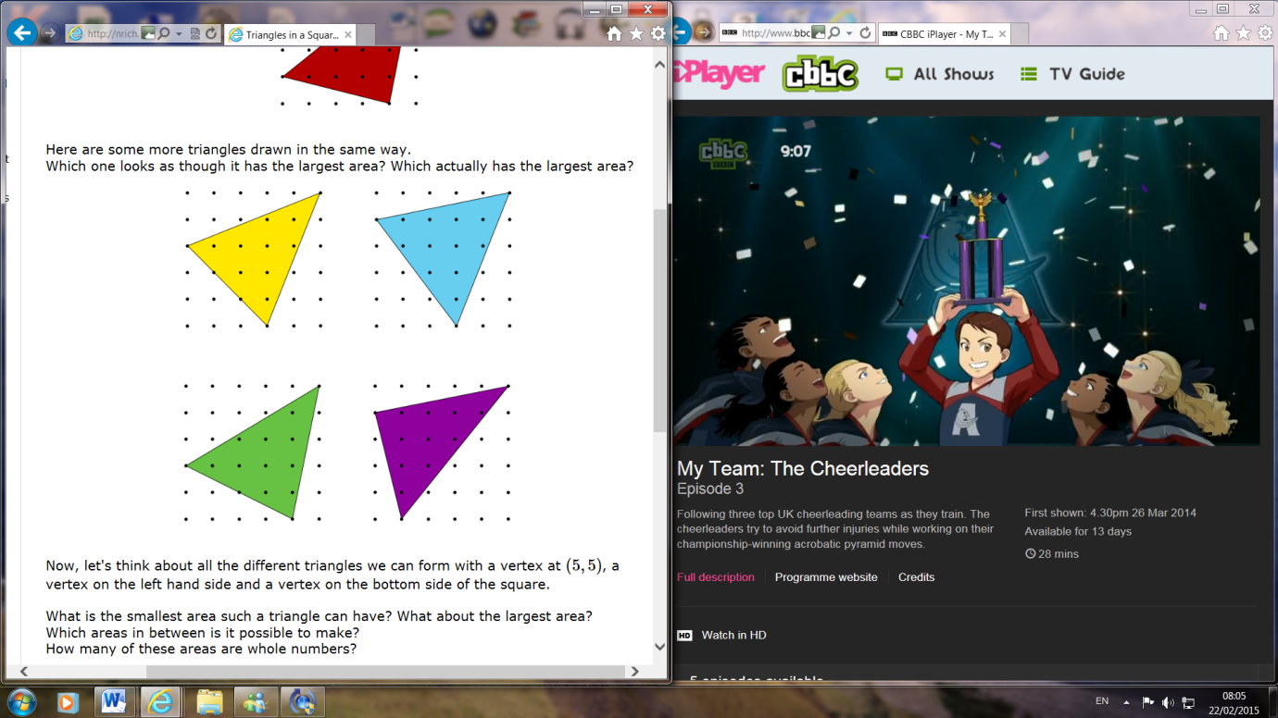
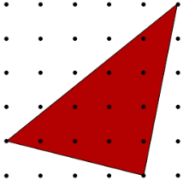
Here is a triangle drawn on a 5 by 5 dotty grid square by joining the top-right-hand dot to one dot on the left hand side of the square, and one dot on the bottom side of the square (red triangle) and some others drawn in the same way:
The area of these triangles looks hard to find without measuring but we can do it by taking away the blank triangles from the area of the whole square. Let’s look at the red triangle:
The green outlined blank triangle has an area of 10cm², the purple outlined blank triangle has an area of 2cm² and the blue outlined triangle has an area of 2.5cm². So to work out the area of the red triangle, you do: 25-10-2.5-2=10.5 So the area of the red triangle is 10.5cm²
We can use this method to find out the area of the other triangles. Yellow triangle: 10.5cm², blue triangle: 11.5cm², green triangle: 11cm² and purple triangle: 10.5cm²
The blue triangle is the biggest! Now, let's think about all the different triangles we can form with a vertex at (5,5) , a vertex on the left hand side and a vertex on the bottom side of the square. Altogether, it is possible to make 35 different triangles. We know this because:
One point has to be here:
If the second point is here:
there are 6 possible options for where the other point can be. This is the same case for all the other points in the blue box. This point: has only 5 other options because the 6th one would be that particular point resulting in a triangle that was a line.
Something to notice is that if the triangle has two points on the vertices at each end of the top line, no matter where the other point is, the area will be the same. This is because the base and the perpendicular height stay the same. This pink triangle is an example of that.
If the point on the left hand side of the square is on the 5th dot like in this blue triangle, for every dot that you move along on the bottom, the area gets bigger by half a squared centimetre as labelled on the blue triangle. The amount the area grows by depends on where the left hand point is. The further away from the
10 10.5 11 11.5 12 12.5
top, you keep adding 0.5 as shown on these diagrams:
As you can see, I have covered all 35 triangles here. The smallest having an area of 2.5 and the largest with an area of 12.5. It is possible to make all the whole and half numbers in between these numbers apart from 9, 7, 6, 5.5, 4, 3.5 and 3. There are 14 different possible areas that you can make. I used the method of taking away the blank triangles to find the area and a formula for this would be: 2.5𝑥+2.5y -0.5𝑥y
The x and y refer to coordinates. The left hand side coordinate would be (0, y) and the bottom one would be (x, 0). If you try out the formula on the red triangle you get 10.5 which is the same as at the beginning!
Area=2.5𝑥+2.5y -0.5𝑥y
Area=10+2.5-2
Area=10.5
Difference:2.5
2.5 5 7.5 10 12.5
Difference:2
Difference:1.5
Difference:1
7.5 8.5 9.5 10.5 11.5 12.5
2.5 4.5 6.5 8.5 10.5 12.5
5 6.5 8 9.5 11 12.5

