NUMBER SHACKS
I started this problem by trying to look for patterns. First of all, the obvious thing is that if you had the middle numbers, it gives the floor number. If you subtract those two numbers, it gives the roof number. After this, I knew there were other patterns as you can’t find the next shack in line with that information. I did spend quite a bit of time puzzling over it but then I spotted 2 things that helped me work out the sequence of shacks.
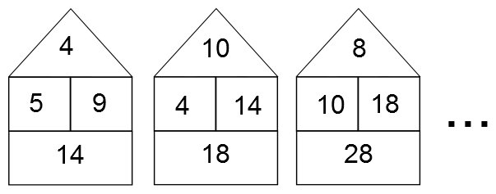

If you take 5 away from 9, which are the numbers on the middle row of the first shack, then you get the number 4 which is the number on the middle row on the left of the next shack. This works with the next number shack: 14 – 4 gives you 10.
I also noticed another pattern. Take the number 9 on the first shack. If you multiply it by 2, you get the number on the floor of the shack, 18. This rule applies to all the shacks.
If we continued the pattern it would look like this:
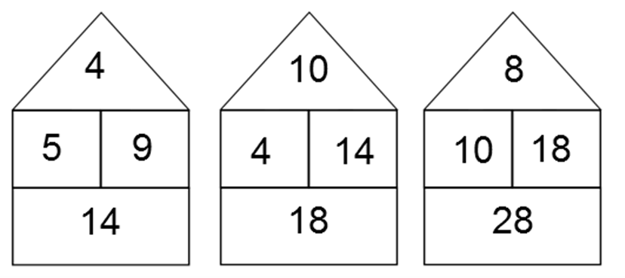
56
16
40
56
36
20
16
36
28
8
20
72

