Our theory (Tom, Morgan and Libby)
Our solution for number shacks is…

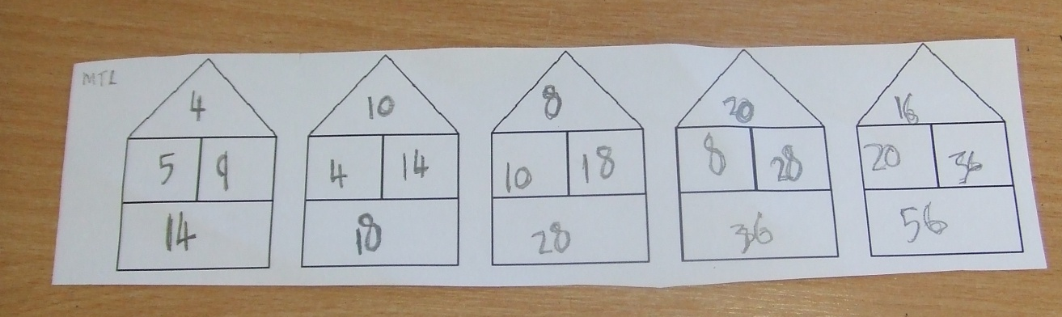
The 5 swaps places with the 4, and the 5 then doubles.

As for the 9 and the 14, they swap too, and the nine doubles. Now you have the numbers in place for the next shack. Then you do the same for the next shack, just with different numbers.

