Ruby, Hannah and Emma’s solution

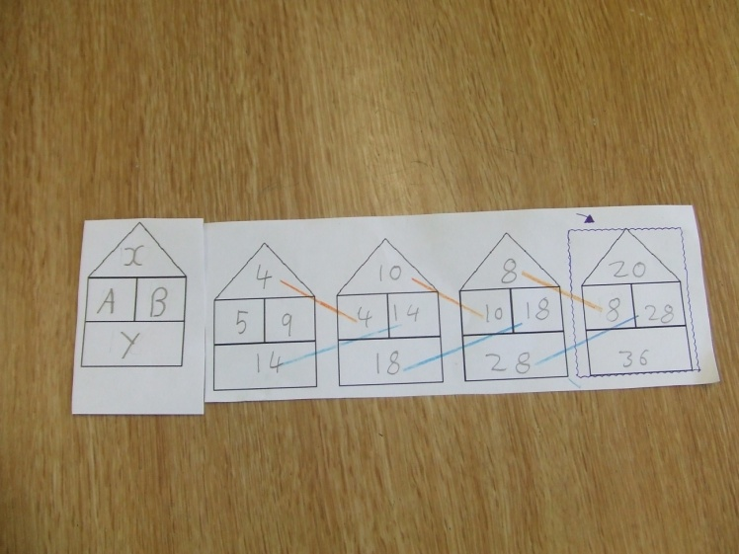
A+B=Y
B-A=X
A+X=B

