Our Theory
On the next shack you take the top and bottom numbers, from the previous shack, to go in the middle. Then you add them together to get the bottom number and take them away from each other to get the top number. 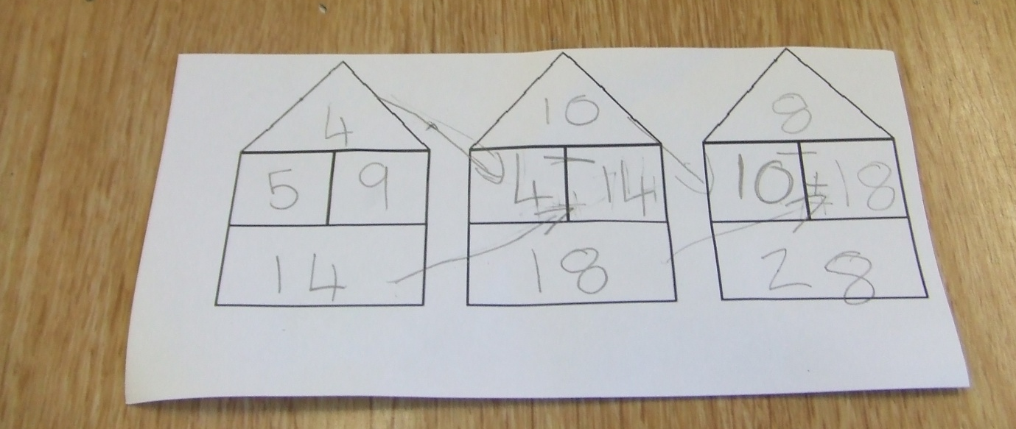
Relation to shacks
The relation to the shacks roofs are:
You start with one of the roof numbers then you go two shack roofs ahead and the number has been doubled. For example: you start with the roof number four and then go two shack roofs ahead and the number has been doubled to eight.

By Ru and Violet

