Nrich Solution for Wipeout (Sat)

This task of Wipeout was taken for 2 sessions with a group of 14 students in Ganit Kreeda, Vicharvatika, India by Shubhangee (facilitator).

The names of the students are:
Ahana, Ananthajith, Dhruv, Sehar, Saanvi, Nikhil, Insiya, Inaaya, Ishaan, Ishanvi, Abhay, Karthik, Vishnuvardhan, Rudra.

Take the numbers 1, 2, 3, 4, 5, 6 and choose one to wipe out. Which numbers can be wiped out from 1 to 6, and leave behind five numbers whose average is a whole number?
Kids together worked on this question and came up with following answer.
We can wipe out 1 or 6 and leave behind five numbers whose average is a whole number.
Children then came up with different observations:
- For any set of 6 consecutive numbers we can always wipe the first or sixth number and the new mean will always be a whole number.
Kids tested it with different examples like
12,13,14,15,16,17
2,3,4,5,6,7
10,11,12,13,14,15
- For other sets of numbers from 1 to N, where N is even, we can always wipe the first or last number and the new mean will always be a whole number.
- For other sets of numbers from 1 to N, where N is odd, we can always wipe the middle number and the new mean will always be a whole number.
- Anathajith explained the 1st conjecture using a variable ‘a’.
He called the first number as a.
Then other numbers will be a+1, a+2, a+3, a+4, a+5.
So, the sum= 6a + 15.
If we subtract a or a+5 from this sum we will get 5a +15 or 5a +10 and both are multiples of 5.

Ahana’s work is shared here.
I tried finding the mean as a whole number with 4 consecutive numbers- 1, 2, 3 and 4. I found out that when we cancel 1, we get the mean as 3, which is a whole number. It also worked when we cancelled out 4, which resulted in the mean as 6. I tried doing this with other consecutive sets with 4 numbers too. E.g.:
3,4,5,6- Wipeout 3, mean is 5 (ALSO) Wipeout 6, mean is 4
5,6,7,8- Wipeout 5, mean is 7 (ALSO) Wipeout 8, mean is 6
Thus, from my observations, when there is a set of 4 consecutive numbers, you can wipeout the first and last number to get the mean as a whole number.
(Reason: We have determined that when we wipeout a number there are 3 left, thus the sum of the numbers after wiping out should be a multiple of 3. If we take the first number to be variable ‘a’, then the rest will be a+1, a+2, a+3. So, the sum will be 4a+6. Now if we subtract ‘a’ or a+3 from it, we will get we will get 3a+6 or 3a+3, which are both multiples of 3)
I found that it is not possible to do this with 5 consecutive numbers, as if we want the first no. to be 1 and the last no. to be an even number, it will not be possible as 5 will have to be the last no.- and it is not even.
Next, I tried this with a six consecutive numbers- 1,2,3,4,5 and 6. I got the answer as when we wipeout 1, the mean is 4, and when we wipeout 6 the mean is 3.
I tried this with:
2,3,4,5,6,7- Wipeout 2, mean is 5 (ALSO) Wipeout 7, mean is 4
3,4,5,6,7,8- Wipeout 3, mean is 6 (ALSO) Wipeout 8, mean is 5
Similar to 4 consecutive numbers I have deduced from my observations that when there is a set of 6 consecutive numbers, you can wipeout the first and last number to get the mean as a whole number.
(Reason: We have determined that when we wipeout a number there are 5 left, thus the sum of the numbers after wiping out should be a multiple of 5. If we take the first number to be variable ‘a’, then the rest will be a+1, a+2, a+3, a+4, a+5. So, the sum will be 6a+15. Now if we subtract ‘a’ or a+5 from it, we will get we will get 5a+15 or 5a+10, which are both multiples of 5)
So, we have reached 2 conclusions-
Conclusion 1- Using any set of consecutive numbers with and odd number of numbers (eg- in 1,2,3,4,5 has 5 numbers in the sequence) we cannot wipeout and get a whole number without breaking the conditions in the question. So, sequences with 7 numbers in them (1,2,3,4,5,6,7) or with 9 numbers in them (1,2,3,4,5,6,7,8,9) etc. cannot be made.
Conclusion 2- Looking at the similarities in the reasons for a sequence with 4 and 6 consecutive numbers we can conclude that sequences with an even number of numbers in them can be made. They fit in with the conditions in the question.
I experimented with other sequences with an even number of consecutive numbers in them, like 8,10,12, etc. and found of that the logic behind them is the same as what I have mentioned in sequences with 4 or 6 numbers
2. What happens when N is odd?
A. Assuming N is odd and we need to make sequences from 1 to N, I have tried the following series of consecutive numbers.
I tried to make a sequence with 3 consecutive numbers first- 1,2,3. When I wipeout 2, I get the mean as 2. I tried other combinations:
2,3,4- Wipeout 3, Mean is 6
3,4,5- Wipeout 4, Mean is 4
(Reason- Firstly, we know that when we wipeout one number there are two left, so the sum after wiping out should be a multiple of two. If we take the first number as variable ‘a’ then the rest of the numbers will be a+1, a+2. So, the sum will be 3a+3. If we subtract the middle number (a+1) from it, we will get 2a+2, which is a multiple of 2)
Next, I tried to make a sequence of 5 consecutive numbers- 1,2,3,4,5 and found out that when we wipeout out 3, we get the mean as 3.
I tried these sequences too:
2,3,4,5,6- Wipeout 4, mean is 4
3,4,5,6,7- Wipeout 5, mean is 5.
Similar to 3 consecutive numbers I have deduced from my observations that when there is a set of 5 consecutive numbers, you can wipeout the middle number to get the mean as a whole number.
(Reason- Firstly, we know that when we wipeout one number there are 4 left, so the sum after wiping out should be a multiple of 4. If we take the first number as variable ‘a’ then the rest of the numbers will be a+1, a+2, a+3,a+4. So, the sum will be 5a+10. If we subtract the middle number (a+2) from it, we will get 4a+8, which is a multiple of 4)
So, we have reached two conclusions again.
Conclusion 1- Using any set of consecutive numbers with and even number of numbers (eg- in 1,2,3,4 has 4 numbers in the sequence) we cannot wipeout and get a whole number without breaking the conditions in the question. So, sequences with 6 numbers in them (1,2,3,4,5,6) or with 8 numbers in them (1,2,3,4,5,6,7,8) etc. cannot be made.
Conclusion 2- Looking at the similarities in the reasons for a sequence with 3 and 5 consecutive numbers we can conclude that sequences with an odd number of numbers in them can be made (with an exception of a sequence with 1 consecutive number(s). For the reason, look at Explanation 2). They fit in with the conditions in the question.
I experimented with other sequences with an odd number of consecutive numbers in them, like 9,11,13, etc. and found of that the logic behind them is the same as what I have mentioned in sequences with 3 or 5 numbers.
3. What happens when you explore equally spaced numbers like:
2,4,6,8,10
3,5,7,9,11,13
3,7,11,15,19,23
2,5,8,11,14.
A. I tried to find out the whole number mean along with wiping one number out for the following-
2,4,6,8,10-Wipeout 6, mean is 6 (ALSO) Wipeout 10, mean is 5
3,5,7,9,11,13- Wipeout 13, mean is 7, (ALSO) Wipeout 3, mean is 9
3,7,11,15,19,23-Wipout 23, mean is 11 (ALSO) Wipeout 3, mean is 15
2,5,8,11,14- Wipeout 8, mean is 8
So, our findings work for all equally spaced sequences.

Here is Sehar’s work:
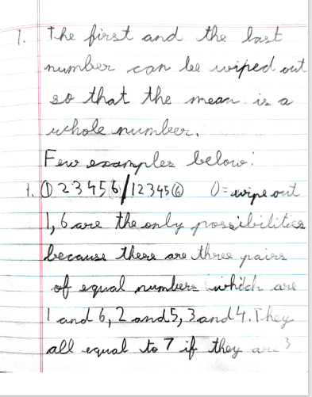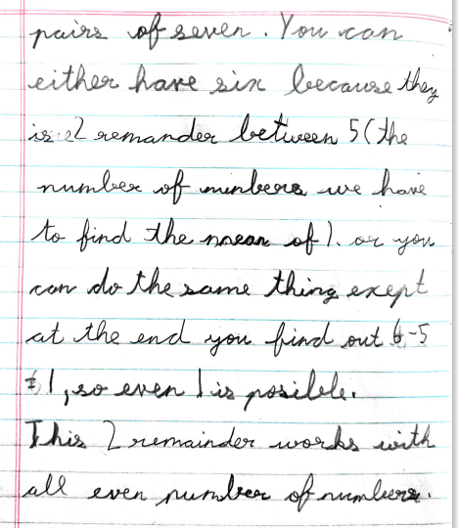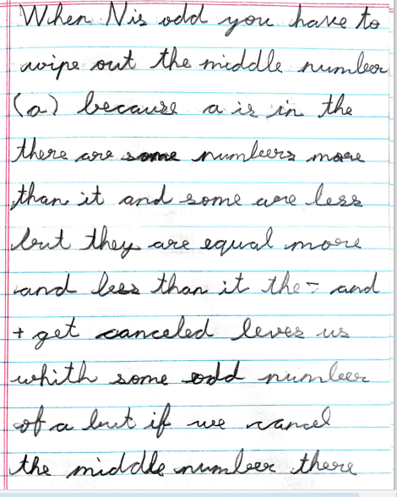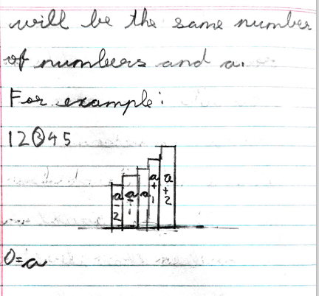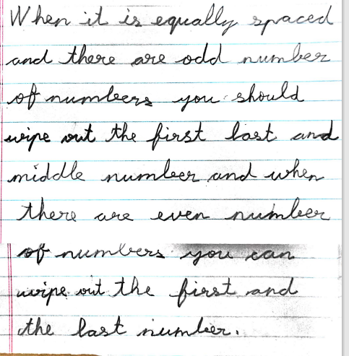

Kids collaboratively came up with following reason for set of 1,2,3…N consecutive numbers where N is odd.

Picture clearly shows
That when N is odd,
The numbers on the
left and right side of the middle number will balance each other and we will get mean equal to the middle number by wiping out the middle number.
When N is even by wiping first or last number, we are left with a set of odd number of consecutive numbers and middle number of these new set will be its mean, as numbers on left and right of the middle number will balance each other.

