Cinema Problem by Team Alpha
In order to complete this challenge you must first try to make a sum of £100. From there we managed to make the amount of people roughly 90 and used trail and improvement to finish our answer of 3 adults, 47 OAPs and 50 children.
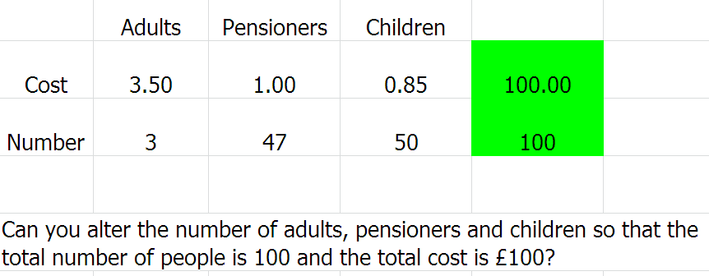
We then looked at the problem again adding other price categories and increasing amount if taking required.
