Year 3 solution (By Jacob, Freddy, Lochlan, Angelo, Alfie, Clemmie, Alice, Zahra, Rafa and Monty from Baobab Class in Sefton Park Junior School, Bristol
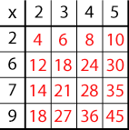
To solve this problem, we first looked at the example grid and noticed that the numbers in red were answers to times table questions. The questions were written in black. Once we understood how the times table grid worked, we started trying to find the missing numbers.
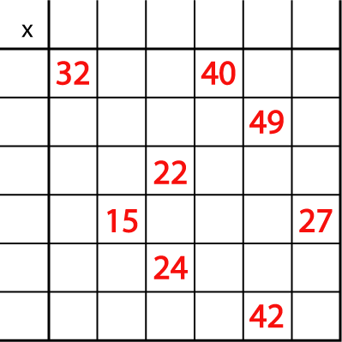
First we looked at the multiples and tried to see which numbers we could multiply together (factors) to make that answer. We knew that 15 and 27 are both in the 3x table so that 3 could be filled out. We know 3x5 is 15 and 3x9 is 27.
Then we noticed that 22 and 24 are both multiples of 2 so we filled out that 2 x 11 = 22 and 2x 12 = 24
One mistake we made was using the number 2 twice. We thought 2 would be in the answers for the 22 and 24 column and that it would be 2x16 = 32 but then we realised we could only use numbers up to 2x 12. (Rafa & Monty)
For the answers 32 and 40 we thought the factors were 8x4 to make 32 and 8x5 to make 40. However we’d already used the 5x table in another column so we had to change the factors so that 4x8=32 and 4x10=40.(Jacob, Freddy and Lochlan)
A learning point for all of us was when we discovered that the only way to make 49 was using 7x7. Then we knew we couldn’t use any other number twice. From that we could work out that 7x 6=42.
Once we discovered all of the factors, we worked out all of the multiples!

