Teddy Town Solution
Ruby and I tried to do the turquoise teddies but we couldn't do it. We had already worked out the one before it by what you can see in the image we are sending you. By the way the colour white is meant to be purple.

So for the first row we put one red and yellow green and blue and purple counter (which were houses) and then paired them up with the same colour die (which were teddies). Then for the next row it was kind of a game where you have a line and if you’re at the front you go to the back anywhere else you move forward. So we put the red house to the very back instead of the front. Then we did the same to the yellow, green and blue. Then we put purple die to the front and red moved down. Then the blue green and yellow moved up to the front like purple. That’s how we figured it out.

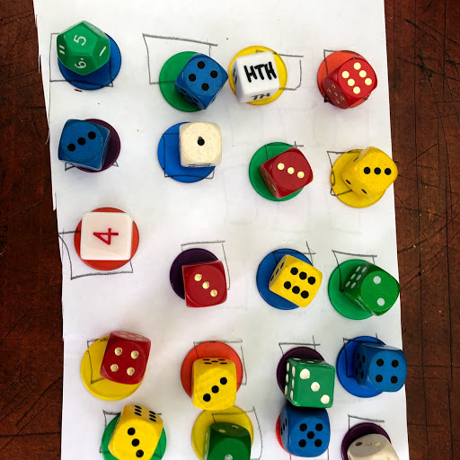

By Ruby and Isabel.
Isabel 9 Ruby 10 years old.

