Who is the best?
By Sophie Minton and Madeleine Quiceno Krueger

First, we created a point system for the medals, to give us easier numbers to work with. Then we looked at the population and found out how many medals/points per million the country owned. We next studied the average GDP, per person, for each individual country. We compared this with their results in the olympics and found out the following:
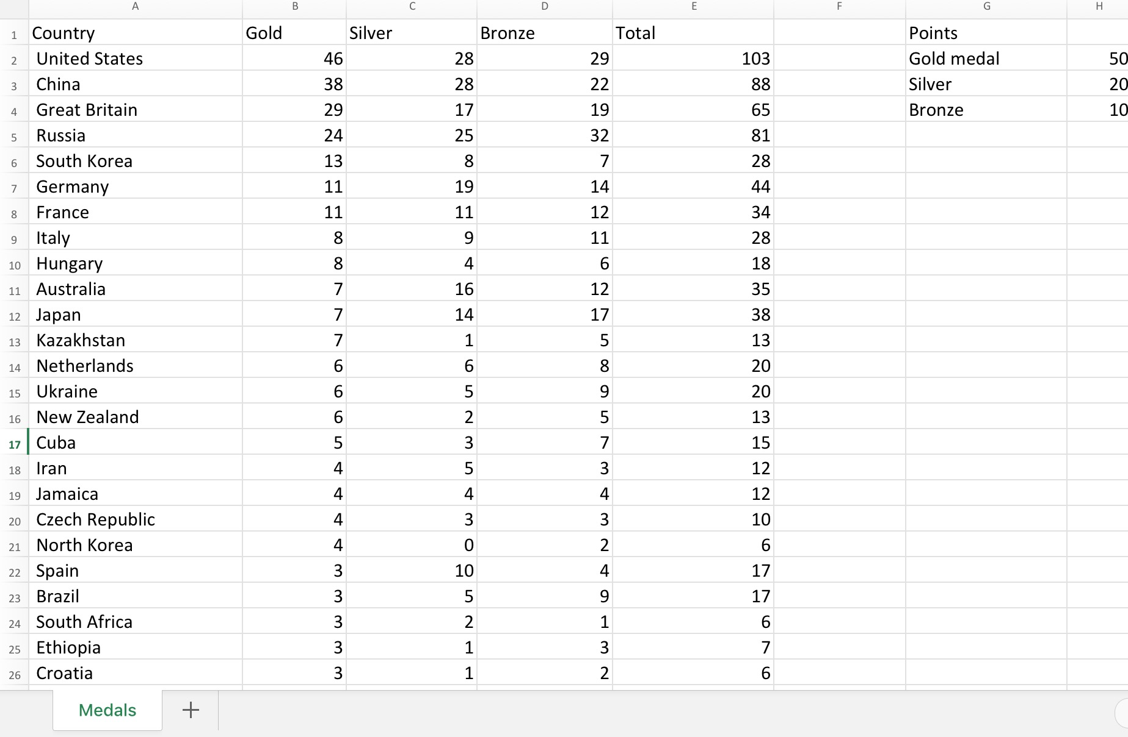
By comparing the population, GDP, Medals per million and Points per million, we concluded that the United States and Jamaica are the 'most athletic nation'. However, it also depends how the nation spends their GDP, shown perfectly by Ethiopia. They had a low GDP, of 505 USD, but won 12 medals in total at the Olympics. They have decided to direct their money towards sport. If we would have more time, we would have looked at the results from other olympics, especially the ones in Rio.

This is our excel which shows the results in the London olympics, and our point system. We decided that one gold medal is worth 50 points, so instead of China having 38 medals, they have 1900 points.

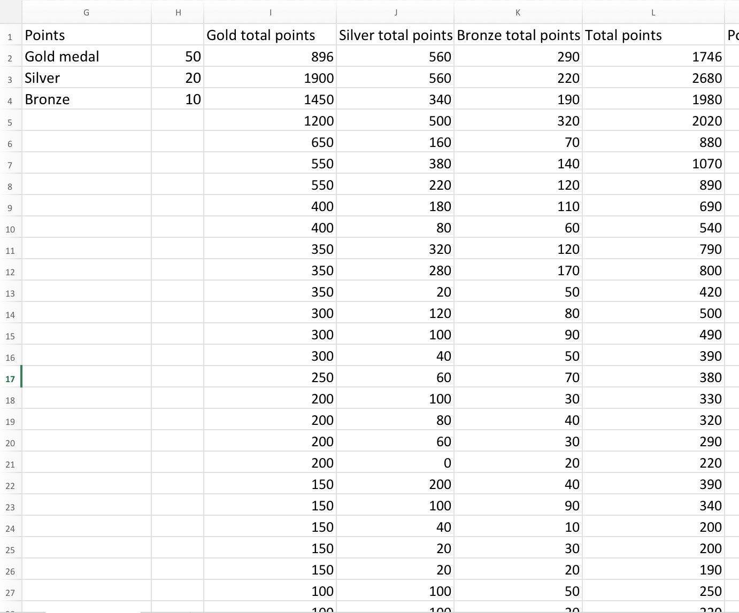
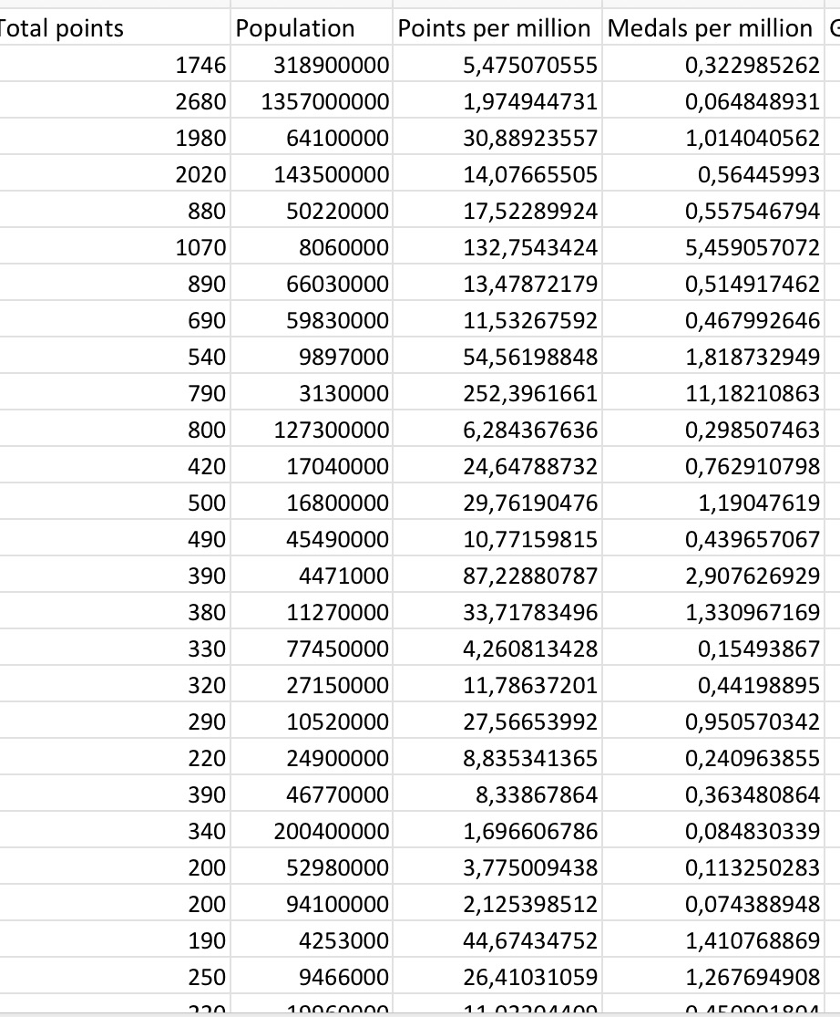
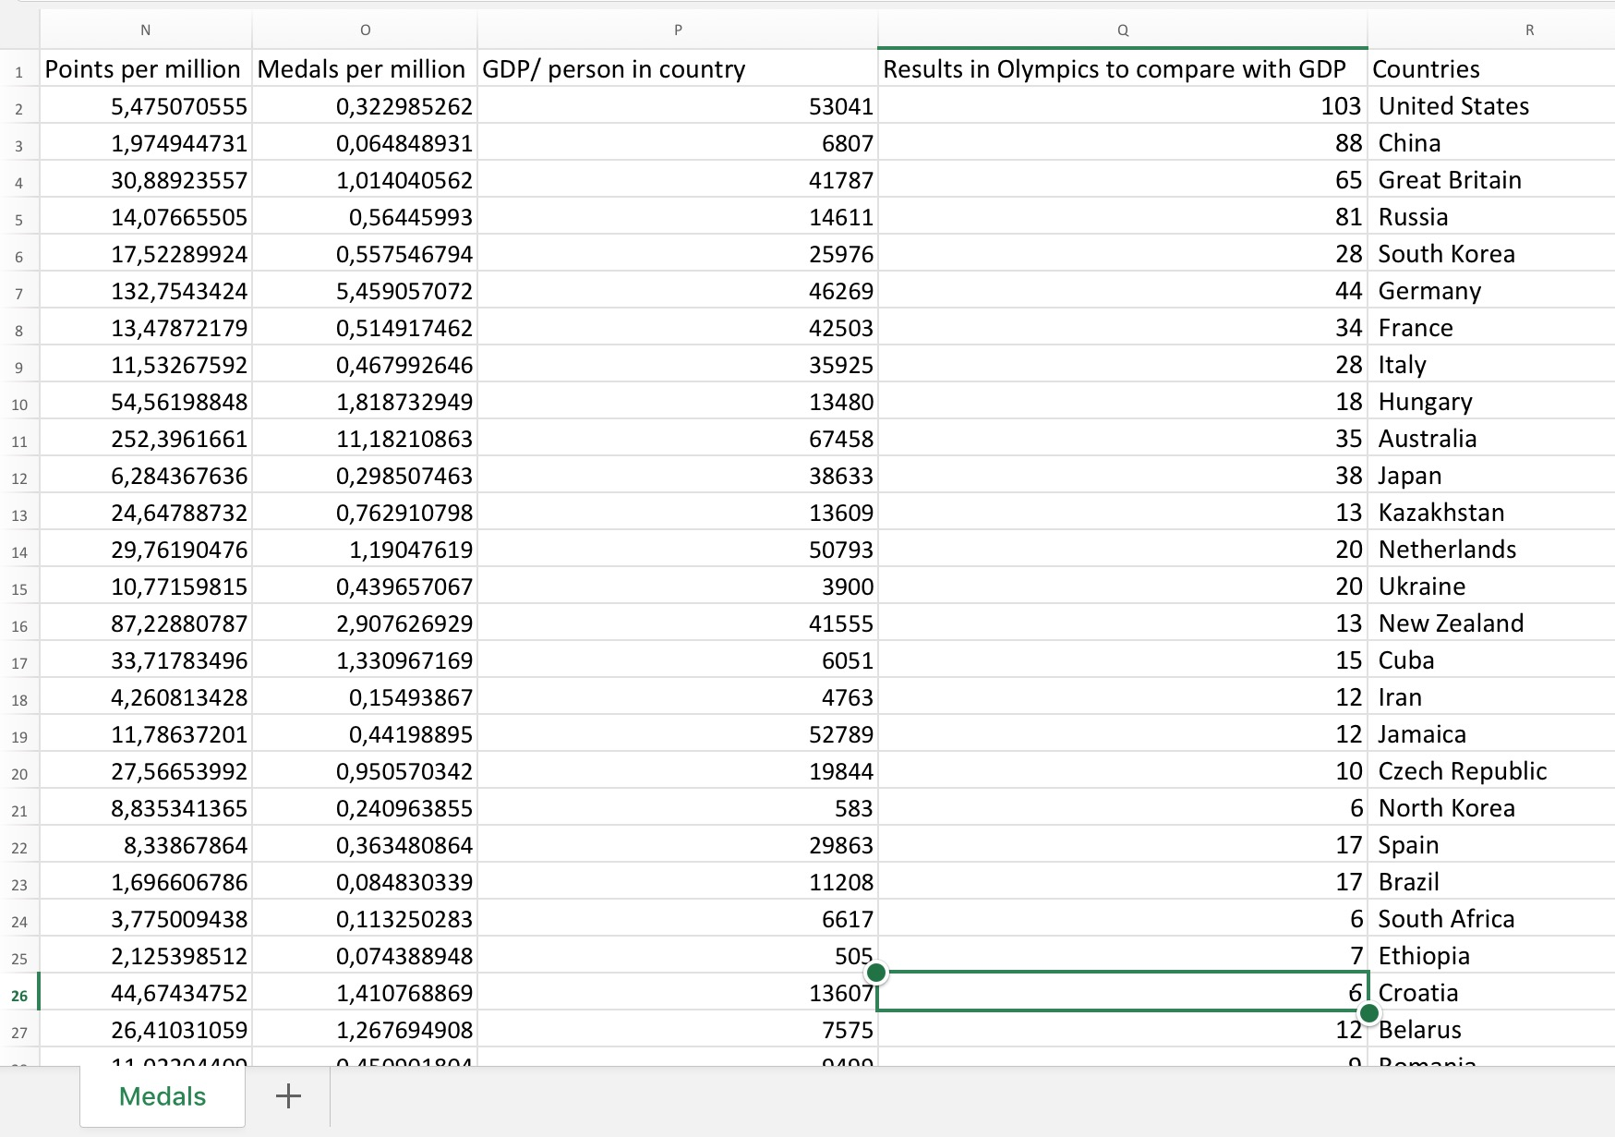
This shows the total gold, silver and bronze points per country. As you can see, they are easier numbers to work with, because next we will be finding out how many points per million people in the country.
Here it shows how we compared the GDP with the results from the olympics, if the country had a high GDP and did well in the Olympics, it suggests that they put lots of that money towards sports.

