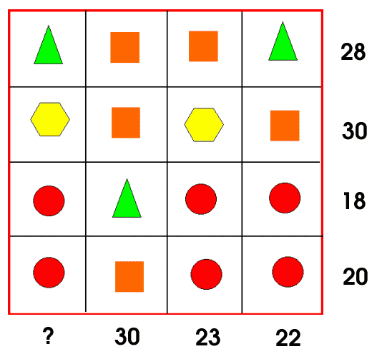
C= column
R= row
C4
C3
C2
C1
R4
R2
R3
R1

- First I looked if there was a row or column which all had the same shapes, however there wasn’t any and so i looked for another row or column which nearly contained all the same shapes.
- Then I found that column 2 and row 3 had nearly all the same shapes however I found that the triangle was the only odd one out in both the column and the row.
- Then I took the number at the end of column 2 and the number at the end of row 3 and subtracted it. (30-18=12)
- As I used a column and a row and therefore used 2 lines I divided the 12 (which I got from subtracting 30-18) by 2. 12 divided by 2 equals to 6. Therefore the triangle was 6.
- As I knew that the value of the triangle was 6, I used row 3 to find out what the circles were worth. So I did 18-6=12. I did this to take the triangle out. Then I did 12 divided by 3 to find out the value of each circle. (12/3= 4) Therefore the circle was 4.
- I did the same method to find the value of the square like the circle. So I did 30-6=24 then 24/3=8. Therefore the square was 8.
- To fond the hexagon I used row 2. Knowing that the squares are worth 8 and there are 2 squares in that row. I did 8+8=16 then do 30-16=14 which was the value for 2 hexagons. To find a hexagon I then did 14/2= 7. Therefore the hexagon was 7.
- To find the answer for column 1 I added all the values of the shapes. (6+7+4+4=21)
Therefore 21 is the value of the question mark.

