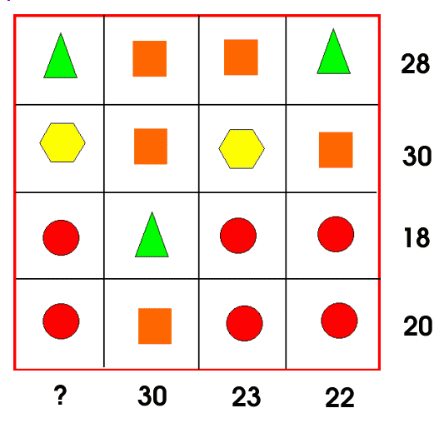
Square-8
Triangle-7
Circle-4
Hexagon-6
?-21

We knew that Square + Triangle = 2Hexagon because there was a row and a column that both add up to 30. They both had two squares, but then one had two hexagons and the other had a square and a triangle, so we went with trial and error based on this.

