What’s it worth? Solution
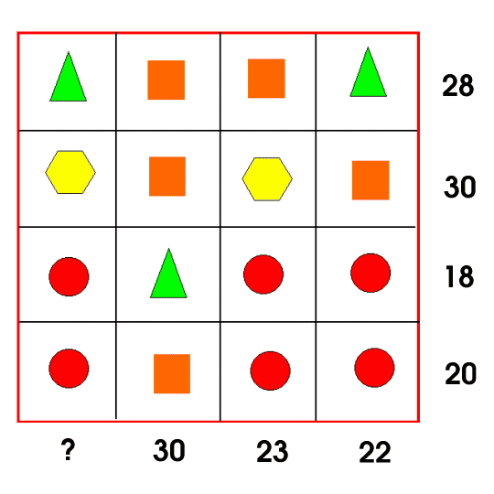
To calculate this solution, you must first think of the second column and the first row. As you can see, they consist of squares (s) and triangles (t). To calculate this I did:
Square Triangle (do this after square)
2s+2t=28 2s+2t=28
3s+t=30 (2x8)+2t=28
S+t=14 16+2t=28
(3s+t)-(s+t)= 2s 2t=12
30-14=16 t=6
2s=16
S=8
After calculating this you can now move on to the bottom two rows. To do this you use substitution (like you did to calculate the triangle). The circles(C) are the ones we want to find out. You do the steps as follows (there are several ways to do this so I will just show 2 of them):
3c+t=18 3c+s=20
3c+6=18 Or 3c+8=20
3c=12 3c=12
C=4 c=4
Now that we have calculated the circles, squares and triangles, we can now move on to calculating the hexagons (h). There are a few ways to do this and I will show a few possibilities:
2h+2s=30 s+h+2c= 23
2h+ (2x8) =30 8+h+(2x4)=23
2h+ 16=30 Or 8+h+8=23
2h=14 h+16=23
H=7 h=7
Finally, we can find out what that mystery number is. We simply use substitution again to calculate it. We do as follows:
T+h+2c=?
6+7+(2x4)=?
6+7+8=?
21=?

