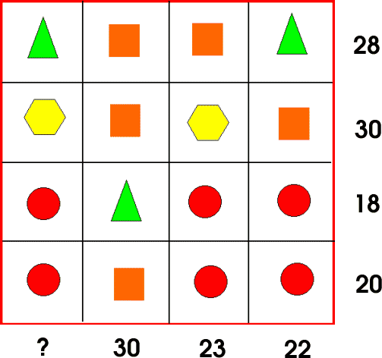
First add up all the numbers on the right had side:
28+30+18+20=96
After finding that out we realised that when all 16 shapes are added together they make 96.
Next what we did was we added up the numbers on the bottom row: 30+23+22=75
Now that you have 96 and 75, minus them:
96 – 75 =21
And now you have your answer: ? =21

