What’s It Worth Solution by Cameron from Prairie Point in the United States
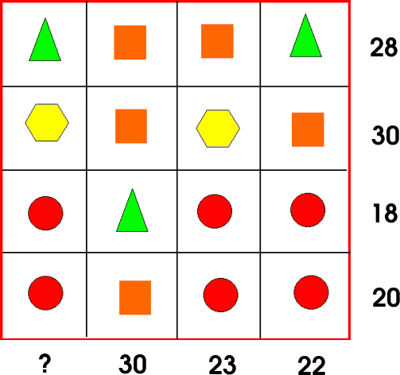

- I started with the 3rd row, because it had 3 circles.
- I covered up the triangle, and divided 18 by 3 (Because there were 3 circles).
- I knew that each circle had to be less than 6, because 18 divided by 3 is 6, and there is also a triangle that needs a value.
- Moving down from 6, I tested if each circle could be equal to 5. I did this by multiplying 5 times 3,(Because there are 3 circles). 18 minus 15 (or 5 x 3) = 3. So, if each circle is equal to 5, each triangle would be equal to 3.
- I moved down to the 4th row and tested if each circle could be 5. There are 3 circles again, so that means we have 15 already, and 15 + 5 = 20. This can’t be right, because each shape must have a different value (this must be true because if every square were equal to 5, and every circle was too, there’s no point in having both shapes!)
- Because each circle can’t be equal to 5, I then tried 4. If each square is equal to 4 in the 3rd row, 3 (circles) times 4 = 12!
- To find out how much each triangle is worth, we take 12 (sum of 3 circles) and 18. We subtract 12 from 18, which is 6, so each triangle might be 6!
- To confirm if each triangle is equal to 6, and if each circle is equal to 4, we have to move on down to the 4th row again.
- If each circle is equal to 4, and there are 3 circles in row 4, that means the 3 circles take up 12 of the 20 (the total for 3 circles and 1 square added together). 1 square: 20 - 12 = 8!
- If everything so far is true, then each circle is equal to 4, each triangle is equal to 6, and each square is equal to 8, then we can confirm this is all right by moving to the 1st row.
- There are 2 squares and 2 triangles in the 1st row. Again, if each triangle is equal to 6, and each square is equal to 8, then the equation is (8 x 2) + (6 x 2) which happens to be 28, the sum displayed on the chart.
- This confirms that 1 circle = 4, 1 triangle = 6, and 1 square = 8.
- Moving on to the 2nd row, where there are 2 squares and 2 hexagons. To find the value of hexagon we have to multiply 8 (the value of each square) by 2, which is 16. 30 - 16 = 14 and since there are 2 hexagons, that means we divide 14 by 2.
- 14 ÷ by 2 = 7, so each hexagon is equal to 7!
- Now to find the value of ?.. In the 1st column, there are 2 circles, 1 hexagon, and 1 triangle. The triangle is equal to 6, the hexagon is equal to 7, and the 2 circles equals 8.
- 6 + 7 + (2 x 4) = 21
- ? = 21!

