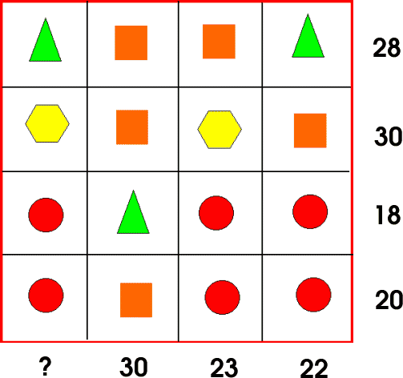

- I made a simultaneous equation from two equations above which had the same shapes.
2t+2s=28 (1)
t+3s=30 (2)

(2)x2 2t+6s=60 (3)
(3)-(1) 4s=32
s= 8
- Then I substituted s=8 & t=6 into other equations:

2h+2s=30
2h+16=30
2h =14
h = 7
- Now I have worked out all of the shapes so I can easily workout:
t+h+c+c=?
t+h+2c =?
6+7+8 =21
3c+t=18
3c+6=18
3c =12
c = 4
Substitute s=8 into:
t+3s=30
t+24=30
t =6
4
7
8
6
s
c
t
h

