First, I organized the domino set in rows by what number was in it. For example, a row of 0 dominoes, and row of 1s.
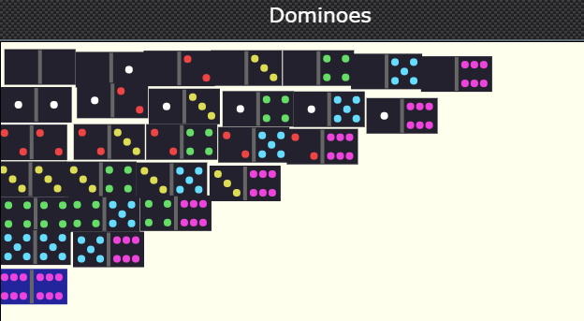
Then I counted how many dominoes there are in a full set and found out there are 28. Then because I knew that she had 24, I knew there were 4 dominoes missing. After that, I added the spots up row by row and I got a total of 168. Amy had 125 spots in her set so I did 168 take away 125 and I was left with 43. I noticed that the total number of spots on each domino could be numbers from 0 to 12. Then I thought what 4 of these numbers I could use to make 43 and I got 12+11+10+10= 43 so the dominoes that were not a part of her bag were:

There are no other possible solutions because there are only two dominoes that have ten spots and only there are only 1 dominoes that equal 11 and 12 spots. All the other numbers would be too small.

