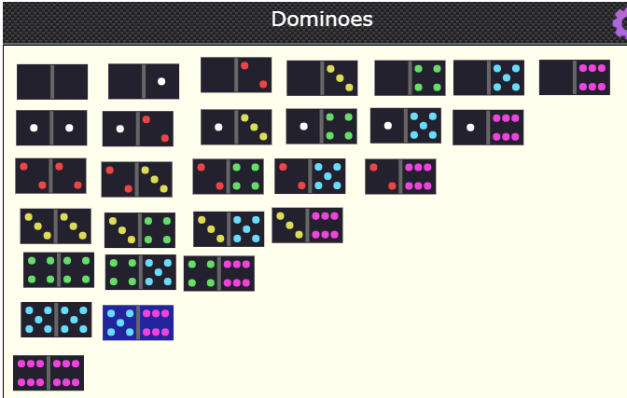
Total for each row:
Row 0: 21
Row 1: 27
Row 2: 30
Row 3: 30
Row 4: 27
Row 5: 21
Row 6: 12

First, I added all the numbers up together to get how many dots there are in a full set of dominoes. After that, I organised the dominos into rows, starting with 0,0 then 0,1 etc (as in the picture above). Next, I counted how many domino pieces there are in a full set (28) and took away the amount she had (24) and I realised that she had 4 pieces missing. Then, I counted how many dots there were in each row and labelled them at the side and added these together to find a total number of dots. There were 168 dots altogether. Then I took away how many dots she had altogether (125) from the amount there is in a full set (168) and I found out the missing dominoes had to add up to 43.
The domino pieces missing were 6,6 5,6 5,5 and 4,6, so 12 dots+ 11 + 10 + 10. There are no other possible solutions because the highest number you can have in a domino is 12 and so any other number will be too small and will not add up to equal 43. There is only one 12 domino, one 11 and two 10s so there is no other way of making 43.

