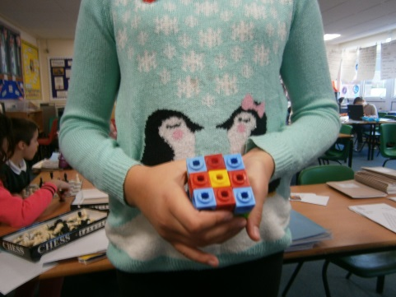
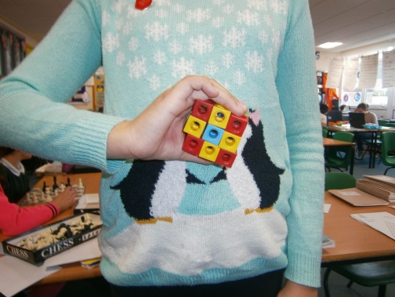
So we put the cubes into a pattern. Then we put one of each colour in a row. At the top there’s four blues, four reds and one yellow. The yellow is in the middle. The four blues are in every corner and the reds are across. Right in the middle is a yellow cube. The yellows formed a cross in the middle of the cube. Here are two pictures showing the top and the bottom of the cube.

