 | 
V = 230 volts  d = 100 m  m = 20 kg | V = 9 volts  d = 1000 m  m = 1 kg | V = 4.5 volts  d = 20 m  m = 50 kg
V = 6 volts  d = 1 m  m = 8 kg | V = 1.5 volts  d = 5 m  m = 11 kg | V = 120 volts  d = 30 m  m = 50 kg
V = 12 volts  d = 500 m  m = 90 kg | V = 6 volts  d = 150 m  m = 6 kg | V = 240 volts  d = 45 m  m = 70 kg

 | 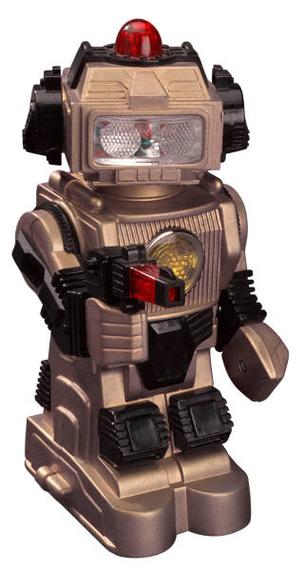
P= 75 W  R = 2 ohms  d = 90 m  m = 10 kg | P= 60 W  R = 5 ohms  s = 20 ms⁻¹  m = 25 kg | P= 15 W  R = 4 ohms  d = 8 m  m = 75 kg
P= 100 W  R = 6 ohms  s = 16 ms⁻¹  a = 4 ms⁻² | V = 9 volts  d = 20 m  a = 1 ms⁻² | V = 120 volts  s = 30 ms⁻¹  m = 80 kg
V = 12 volts  s = 25 ms⁻¹  a = 2 ms⁻² | P= 1000 W  R = 10 ohms  s = 8 ms⁻¹  m = 130 kg | P= 2000 W  R = 16 ohms  d = 9 m  a = 0.5 ms⁻²

I = 2 A  t = 5 s  F = 10 N | I = 0.5 A  t = 1 s  F = 200 N | I = 1 A  t = 2 s  F = 100 N
I = 0.25 A  t = 20 s  F = 15 N | I = 8 A  t = 60 s  F = 1000 N | I = 12 A  t = 30 s  F = 150 N
I = 6 A  t = 15 s  F = 50 N | I = 2 A  t = 45 s  F = 2000 N | I = 1 A  t = 16 s  F = 1 N

I = 5 A  t = 8 s  F = 16 N | I = 4 A  t = 2 s  F = 8 N | I = 7 A  t = 200 s  F = 10 N
I = 10 A  t = 0.5 s  F = 25 N | I = 3 A  t = 150 s  F = 125 N | I = 1 A  t = 90 s  F = 800 N
I = 4 A  t = 32 s  F = 160 N | I = 10 A  t = 240 s  F = 20 N | I = 0.5 A  t = 65 s  F = 40 N

I = 6 A  t = 8 s  F = 80 N | I = 8 A  t = 2 s  F = 30 N | I = 2 A  t = 200 s  F = 900 N
I = 9 A  t = 10 s  F = 300 N | I = 4 A  t = 1 s  F = 150 N | I = 10 A  t = 50 s  F = 60 N
I = 3 A  t = 25 s  F = 350 N | I = 1 A  t = 100 s  F = 70 N | I = 12 A  t = 20 s  F = 2 N
Could change some times to min/hour, lso chnge mss, distance nd speed units

Currents could be decimls

