Part 1(a)
Take two numbers that differ by 2, multiply them together and add 1 (so for example 5×7+1=36).
Try this for some more pairs of numbers which differ by 2.
What do you notice? Is this always true? Can you prove your conjecture?
Here are some ideas to help you prove the conjecture.
Charlie’s method: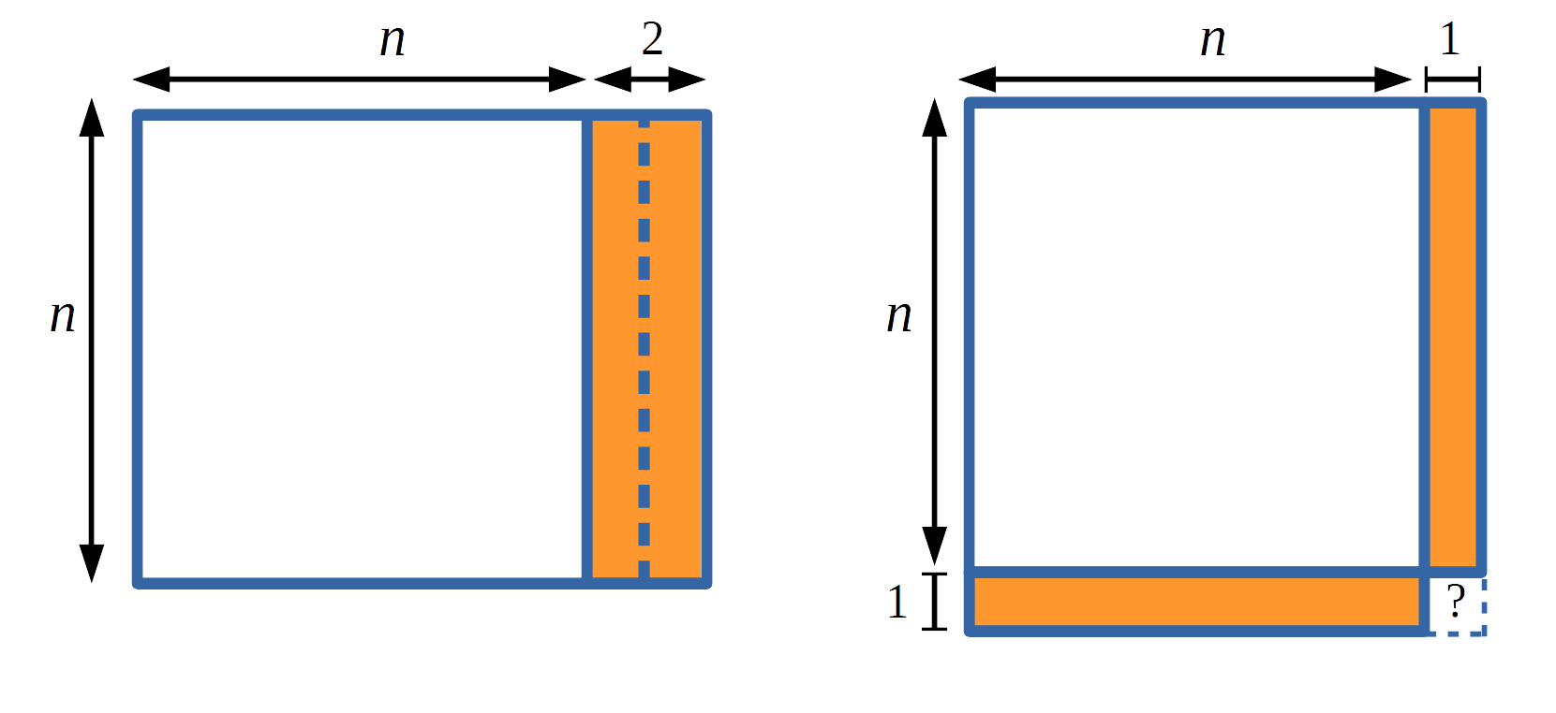
Claire’s method: $n(n+2) +1= n^{2}+ ... =(n+ ?)(n+ ?)$
Part 1(b)
Now take two numbers that differ by 4, multiply them together and add 4
(so for example 5×9+4 =49).
What do you notice? Can you make and prove a conjecture?
Part 1(c)
Now take two numbers that differ by 6, multiply them together and add 9.
What do you notice? Can you make and prove a conjecture?
Part 1(d)
Looking at your results for parts (a), (b) and (c) can you predict what you will have to add to the product of two numbers that differ by 8,10,12,...,2k in order to get a square number?
Can you write down a general statement? Can you prove this statement?

