A car's milometer reads 4631 and the trip meter has 173.3 on it:

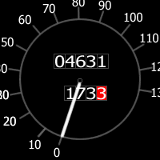

How many more miles must the car travel before the two numbers contain the same digits in the same order?

Can you find some other starting numbers that will lead to matching pairs?

What is the relationship between two starting numbers that will work?

If the milometer and trip meters had the following exact readings (4632 and 173.3) then the two numbers will not contain the same digits in the same order before the milometer reaches 99,999 miles. Why is this?

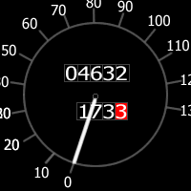

If the milometer 'loops the clock' back to 00000 again at 100,000 miles and the trip meter loops the clock back to 000.0 at 1000 miles, will the two numbers ever contain the same digits in the same order?

