This is how Mrs Freer’s Year 8 Set 1 class at Swavesey Village College, Cambridgeshire, tackled Pick’s Theorem.
The students were shown the following shape on the board and asked to discuss for 2 minutes in groups what the area of the blue polygon is.
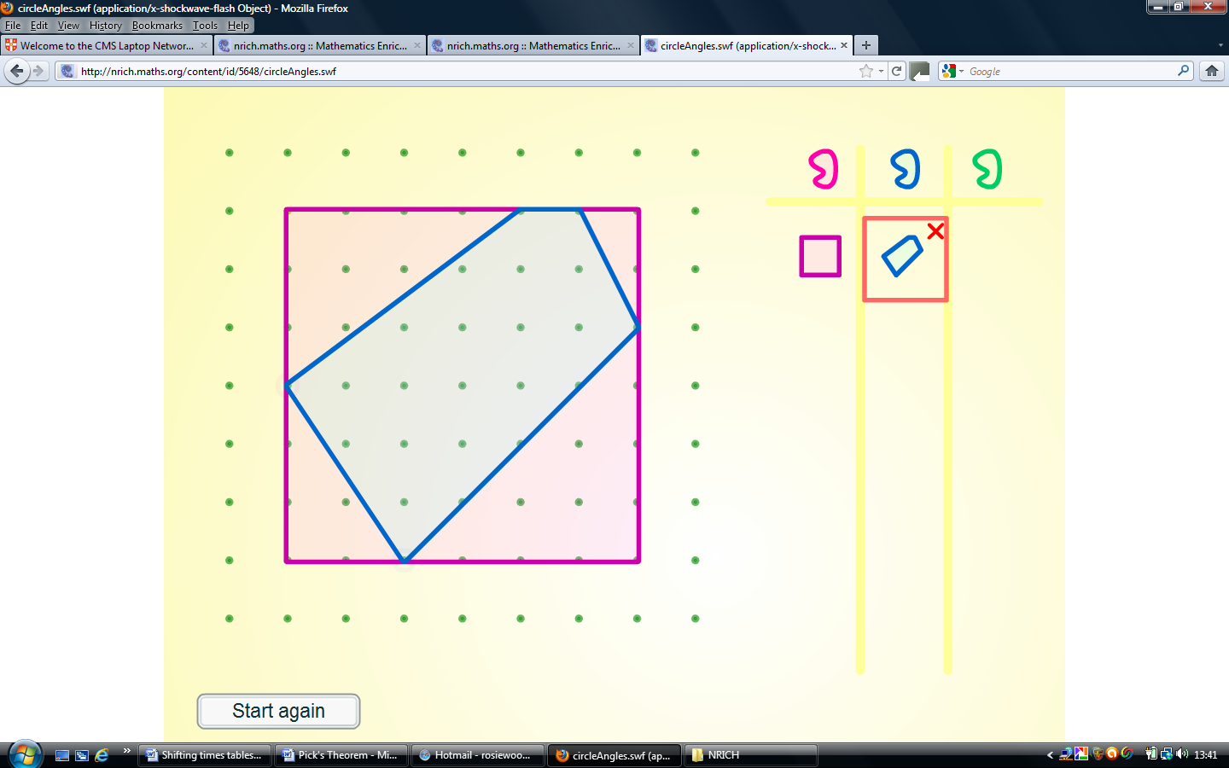

The teacher emphasised that the focus was the method rather than just the answer so during open class feedback a number of methods were discussed including, calculating the area of the triangles around it and subtracting them from the square; dividing the shape itself into rectangles and triangles; and counting the squares inside the shape.
The students were then put into groups of 4 and each student was given a role to promote comprehensive group work. One student was responsible for recording and publishing on behalf of the group; one student was in charge of resources; one student was the verbal communicator and one had to ensure every member was included and involved. Roles were distributed randomly (students selected a role card, which can be found below). The students were told to put their books away and were given a large piece of paper for making a poster of all their ideas and a small copy of the Pick’s Theorem poster (http://nrich.maths.org/5954) which explained the task. The resources manager was allowed to stand up and get glue, scissors, paper etc that the group needed so communication between members was key. They were also allowed to go to the whiteboard to use the interactive pegboard (http://nrich.maths.org/public/viewer.php?obj_id=2883) if necessary, although most students were happy to draw straight onto square dotted paper. The students had 10 minutes to read through the problem and make a start. Meanwhile the teacher monitored the groups closely and offered assistance and encouragement when appropriate. This included checking that each group understood the problem.
A mini plenary discussion took place to ensure students had the opportunity to compare their work with other groups and to ensure they were on the right track.
T: ‘So you’ve all understood the problem and been able to make a start. Tell me what your group has been up to.’
S: ‘We’ve just been seeing how many (4,0) shapes we can draw. I think it’s infinite because I can make a line attached to the shape go on forever.’
T: ‘Ok so what do you think you need to do next?’
S: ‘Work out the areas.’
T: ‘Good. Has anybody got that far?’
S: ‘We worked out that the area for (4,0) shapes is 1.’
T: ‘Is this always true?’
S: ‘Well it worked for all our shapes and we think it’s always true because if you have an elastic band on the board and just move it around the pegs then you’re only changing the angles so the area stays the same. Now we’re seeing if there’s a pattern when looking at different shapes like (5,0) and (6,0). We should be able to make a formula once we’ve worked out more areas.’
T: ‘So what are you keeping the same and why?’
S: ‘We’re keeping i the same so it’s easier to spot a pattern.’
The students were given a further 10 minutes to try to come up with some more conclusions. During monitoring, the teacher encouraged students to make conjectures and to ensure they do enough examples to convince the class their conclusions are always true. The students were then given 5 minutes to write up their findings on the poster, sticking any shapes they’d drawn onto it and making sure everything was labelled and clear. Some groups shared their findings with the class.
T: ‘What has your group been doing?’
S: ‘We drew tables to show our findings for the areas of different shapes with 1 internal point and then 2 internal points. We only had time to work out that area = p/2 – 1 when i=0.’
T: ‘Everyone agree, disagree? Well done. Now did anyone get further than that?’
S: ‘We found an equation for the area of any shape.’
T: ‘How did you do that?’
S: ‘We did the same as the other groups but split up the work so some did (4,0), (5,0), (6,0) shapes and some did (4,1), (4,2), (4,3) shapes. We think it’s area = p/2 -1 + i.’
This task was very interactive and encouraged independent investigation as well as peer teaching. Many students commented that they enjoyed doing it because they ‘felt clever’ because of the satisfaction of working out the theorem for themselves.

Role Cards
Resources & Representing
- Select materials for your team. – you are the only person who can leave your seat.
- Make sure resources are used – help create calculations, diagrams etc. for the presentation
- You are the only one who can ask the teacher any questions so make sure your team agrees.
- When your team thinks you have completed all the tasks fully call the teacher over.

Recording & Publishing
- You need to collect, write down and visually present all your results. You need to show everyone’s ideas, all calculations, and important explanations.
- You can include colour, charts, tables and diagrams to communicate your mathematics, reasons and connections.
- “How do we want to show that idea?”

Inclusion
- Make sure your group reads all the way through the task together before you begin.
- Make sure everyone’s ideas are heard.
- Invite others to make suggestions.
- “Did anyone see it a different way?”
- You must make sure your team mates do not talk outside your group!

Verbal Communication / Spy
- Be sure everyone in your group can convincingly explain your group’s thinking.
- If you don't understand, ask whoever had the idea ... if you do, make sure everyone else does too.
- Make sure that all of the important parts of your discussions get written down.
- On occasions the teacher may ask you to move to another group to ‘spy’ or give them clues from your ideas.

adapted by Mrs Freer from E.Cohen (Designing Group, 2004), NRICH and F. Wilson (Parkside School)

