In this activity, we are going to shade the squares of this grid with one colour to make different designs.
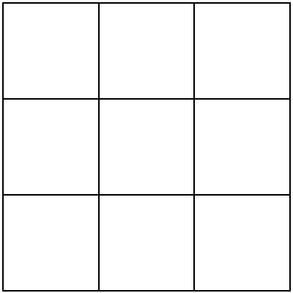
There are a few rules that our designs need to follow:
- Whole squares have to be shaded, rather than parts of squares.
- Each design must have at least one line of symmetry.
- Each new design you come up with must be different from all of the others. If two designs would look the same if you rotated or reflected them, they do not count as different designs in this task.
Have a go at making some designs. How many can you find? You might like to shade your designs on squared paper.
If you wanted to find every possible design, how would you do this?

