Here is a set of ten cards, each showing one of the digits from 0 to 9:
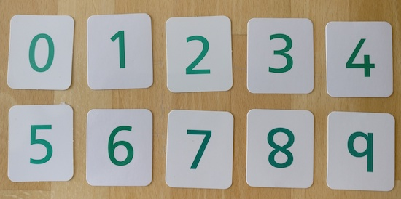
The ten cards are divided up between five envelopes so that there are two cards in each envelope.
The sum of the two numbers inside it is written on each envelope:
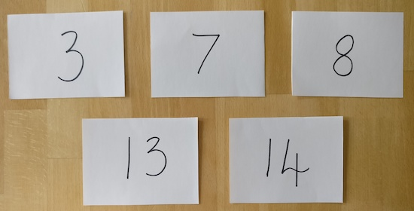
What numbers could be inside the "8" envelope?
Thank you to Alan Parr who inspired this task.

