Imagine a three dimensional version of noughts and crosses where two players take it in turn to place different coloured marbles into a box.

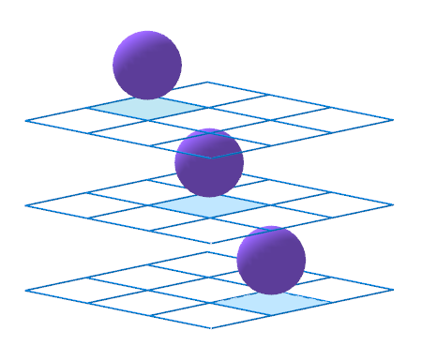

The box is made from 27 transparent unit cubes arranged in a 3-by-3-by-3 array.
The object of the game is to complete as many winning lines of three marbles as possible.
How many different winning lines are there?

