What is a tetrahedron? Here are four different triangles made from Polydron (plastic shapes which click together):
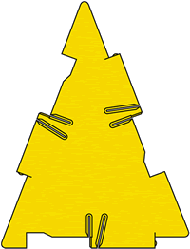
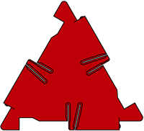

Small equilateral Isosceles
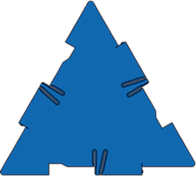
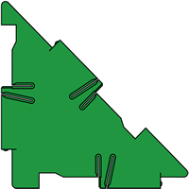

Right angled isosceles Large equilateral
The sides of the small equilateral triangle are the same length as the short side of the isosceles triangle and the short sides of the right-angled isosceles triangle.
The sides of the large equilateral triangle are the same length as the long sides of the isosceles triangle and the long side of the right-angled isosceles triangle.
You have an unlimited number of each type of triangle.
How many different tetrahedra can you make? Convince us you have found them all.

