The planet of Vuvv has 7 moons which lie spread out on one plane in a great disc round it. These Vuvvian moons all have long and confusing names so scientists usually call them by their initials: A, B, C, D, E, F and G starting from the nearest one to the planet.

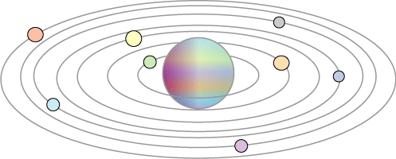

When two of these moons line up with the planet it is called a 'lunar eclipse'. When three line up with the planet it is called a 'double eclipse', when four do it is a 'triple eclipse' and so on. Once in a while all seven moons line up with the planet and this is called a 'super-eclipse'.
Moon A completes a cycle round the planet in one Vuvvian year, moon B takes two years, moon C takes three years, moon D takes four years and so on.
How long is it between each 'super-eclipse' on the planet of Vuvv?

