Here are nine triangles. Each one has three numbers on it.
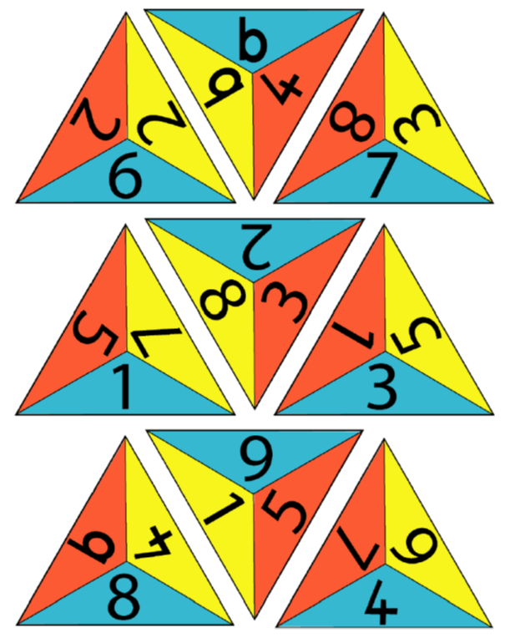
Your challenge is to arrange these triangles to make one big triangle, so the numbers that touch add up to 10.
Once you've finished making the big triangle, think about these questions:
How did you get started?
What did you do next?

